School of Electronics and Computer Science

Faculty of Physical and Applied Sciences

University of Southampton

Saber HAMIDI

26th April 2016



**The Use of Social Networks for Marketing**

Figure Graphical representation of social media marketing <http://www.getsticky.com.au/3-reasons-to-hire-a-specialist-for-your-social-media-marketing/>

Project supervisor: Professor Leslie Carr

A project progress report submitted for the award of

MComp Information Technology in Organisation

# Abstract

Social media, online presence, and e-commerce have changed the way restaurants businesses do marketing, and promote their brands. However due to no budget to invest in technology, and lack of expertise, small local restaurants and takeaway shops are left behind when it comes to online presence. This project aims to implement a social media-marketing platform that enables small local restaurants to grow a network of customers online, and promote their brands using that network. This progress report focused on social media marketing background research, which includes, existing solutions, and the project aim & objectives. It continues to the requirements analyses, and the project plan for implementing the platform. The plan includes the system Gantt chart and the system architecture design. Plan for the remaining work includes implementation of the system, testing and deployment.

# Contents

Abstract 2

Contents 3

1. Introduction 4

1.1 Problem 4

1.2 The Project Goals 4

1.3 Scope 4

1.4 The Project Changes 4

2. Background Research 5

2.1 Existing Attempts and Solutions 5

2.2 Related Work 7

2.3 The Project Aims 7

2.4 The Project Objectives 7

3. The Requirements Gathering 9

3.1 Functional and Non-Functional Requirements 9

4. The Project Plan 10

4.1 Initial Design 10

4.1.1 Campaign Walkthrough 11

4.1.2 Major Platform Functions 11

4.2 Gantt Chart 12

5. Summery of Work to Date 13

6. Plan for the Remaining Work 14

7. References 15

8. Appendices 17

# 1. Introduction

## 1.1 Problem

I have already built a website for a restaurant called “British Dining”. It allows customers to order online, and my plan for the future is to develop the same website for hundreds of other restaurants around the UK.

The restaurants have no means of marketing and distributing their food advertisement in a technological way. TV adverts and spreading leaflets fliers are very costly, and plus specific customers can’t be targeted this way.

## 1.2 The Project Goals

My agreed project is based on creating a smart-system that enables restaurants & take away shops to create, manage and deploy social media campaigns to their customers. The customers can then share the campaign with their friends and families, for which they will receive rewards, e.g prize winner / increase in their Loyalty-balance. This will enable clients to grow their business networks.

This promoting system will also consider utilising social media ID (#TwitterID) of every single user that has made an order to the restaurant, to advertise to them the relevant types of food that they might like, based on analysing their social network activities. This smart system will enable the restaurants to target specific customers for specific food advertisements and marketing, using social networks.

Building a system like this hugely relies on accessing social media libraries in order to fetch users posts and tweets. Therefore the problem of privacy may get in the way, however it will be dealt with in the users agreement.

## 1.3 Scope

The user of this system will be the restaurants and their consumers. This project is only focused on the marketing system of the restaurants businesses. Therefore it includes advertising through social media, launching social media campaigns, and to grow the marketing network. The scope of this project does **not** cover online ordering facility, or building website for the restaurants and takeaway shops. Payment processing is also considered to be **outside** the scope of this project.

## 1.4 The Project Changes

The main project aim agreed to be personalised promotion using social media, at first. However after having finished the background research, it has been agreed with the supervisor that the project should also include two types of social media marketing campaigns too. It was agreed because, as a result of background research, social media campaigns proved to be as successful way of social media marketing for small businesses.

# 2. Background Research

Despite the huge attention of restaurants businesses on engaging with their customers using social media, a lot of them have no online presence. Therefore they are left behind, when it comes to smart marketing, where use of mobile phones and grow of social networks have changed the way people and businesses interact [11]. It is reported that still 65% of the restaurants are not online, which means they not taking advantage of e-commerce, neither they make use of social media marketing [1]. Most of them are small, local takeaway shops, with no budget to invest in technology or in technological marketing. This has caused them to consequently miss the opportunity that social marketing brings to boost their sales [1]. This project will enable all of those restaurants businesses that are fallen behind, to catch up with today’s modern technological way of marketing and engaging with the customers in a new way.

On the other hand almost all of the big businesses in fast food industry like Domino’s Pizza, Pizza Hut, Papa Johns etc. have already started e-commerce from as early as 1994 [12]. In addition they also take advantage of social media marketing. Since technology is getting more advance every year, and mass distribution of smartphones and use of Internet is changing the way we live and do things, the big restaurants and fast food businesses have understood the importance of investing in e-commerce, as well as making use of social media marketing to run their businesses parallel with todays technology [13]. Domino’s Pizza has reported that 75% of their sales in 2015 were online, and more than half of these sales have come through their mobile app [2].

## 2.1 Existing Attempts and Solutions

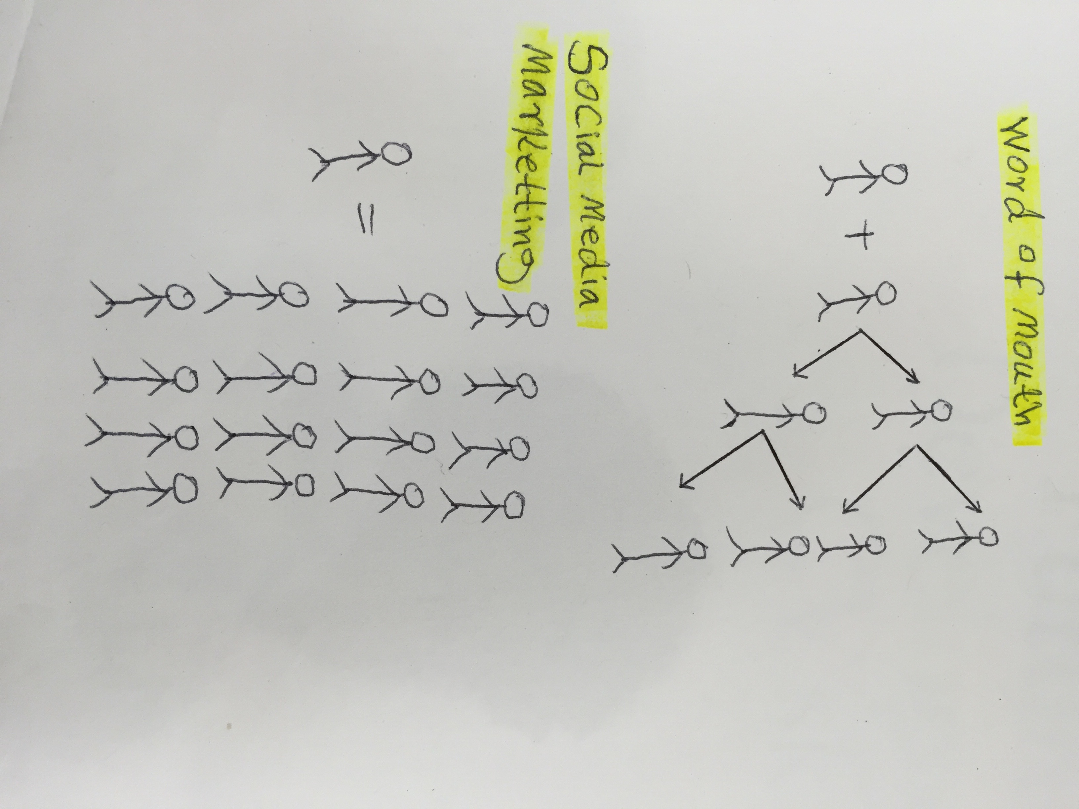Having researched the use of social media for marketing prospective, it is found that already businesses are taking advantage of the mass amount of users social media have every minute. Fast food businesses and restaurants trying their bests to stay ahead of the game, and attract as many customers as possible, using social media marketing [14]. They have even tried to target relevant customers with the use of social media, because it has been known the most popular activity on the web [3]. On the other hand **some third party aggregators such as Just-eat and Hungryhouse are also already dominant in terms of web presence, ordering faculties, and payment processing for the restaurants [15]. However they haven’t touched the field of marketing to enable small brands to promote themselves.**

On April 2014 Qdoba (Mexican restaurant chain) opened a social media campaign that enabled Qdoba Queso sauce eaters to vote for their favorite Queso sauce [4]. A total of more than 30,000 voters participated in the campaign. **Figure 3** shows visualized information about the campaign result by Qdoba.

Figure Word of mouth VS social media marketing

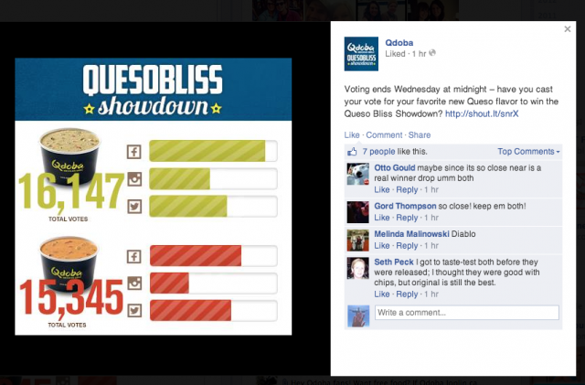

Figure Qdoba Queso compaign screen shot

For Qdoba restaurant this is an official way of connecting customers with their products, and it means that, their voice gets heard by thousands of people out there. This has had a positive effect on their sales and building their brand image [10]. In addition to that, by analysing the customer’s tweets and comments the restaurant can learn a lot about their customer’s desires, and they can tailor their promotions according to their needs, which will result in huge success in the long run.

On Jun 2015 Havana Restaurant & Bar also held a Giveaway Campaign for the participants to win a free one-hour bar for the winner and nine of his/her friends. The participant were asked to like the restaurant Facebook page and write “Open bar” on their Facebook wall, following them on Twitter and tweeting name of the restaurant, as well as signing up for their emails [5]. Check **appendix 1** for more social media examples.

The two restaurants (Qdoba, Havana) both promoted their campaigns using Wishpond, which is a third party marketing platform, that runs, track, and manage different social media campaigns, not only for the restaurant firms, but also for any other brand [16]. **[Read more about Wishpond on Page 7]**

Qdoba and Havana restaurants social media campaigns are only two examples of how businesses bring awareness about their brands and promotions through Facebook and Twitter. Many restaurants have set up official accounts on social media, having tried different ways of marketing, from campaigns to offering discount for specific group of followers, to engage with customers and learn as much as possible about their expectations.

## 2.2 Related Work

**As the description clarifies, the aim of this project is to develop a smart system that enables restaurant businesses to analyse customers’ activities through social media and subsequently target them for a specific products or promotions. Having researched the closest attempt for targeting relevant customers through social media marketing is done by Wishpond, which is a platform that provides businesses with social media campaigns, and many other marketing tools such as; website popups, online forms, marketing automation, email marketing, retargeting ads and marketing analytics [16]. They uses the power of social media to drive traffic to the advertiser’s website. It uses Target Ads feature of Facebook to target customers in a specific geographical area [6]. However unlike the aim of this project Wishpond haven’t gone that far to analyse customer’s social media activity for personalised promotions targeting.**

## **2.3 The Project Aims**

**Some high value fast food companies with big budgets, e.g. Domino’s and Pizza-Hut are already dominant in terms of having established their own online-presence, e-commerce, and marketing. This project aims to build a social media-marketing platform that is focused on small restaurants and takeaway shops who have no investment in technology. This system will brings the marketing functions of big brands to the small restaurants and fast food businesses, using social media. It will advance the retails system of small businesses with small budgets in the fast food sector to take advantages of the same marketing intelligence as Domino’s & Pizza-Hut, which is otherwise far less, affordable for them.**

## **2.4 The Project Objectives**

**The objectives considered in this project are;**

* **Finding the right social media campaigns for small restaurants businesses, with small budget, and hyper local audiences**
* **Creating a platform for the relevant social media campaigns, and personal advertisement**
* **Evaluate the system by running a real campaign as a trial on one of the local restaurants in the town**

Having revised the variety of social media marketing campaigns Wishpond offer to businesses, the restaurants targeted in this project suffer from having no online presence and no social media followers yet. Therefore this project will also focus on two types of social media campaigns that deliver the promoting voice of the restaurant businesses to as many customers as possible, while growing the marketing network at the same time, for sales improvements. This will enhance a big opportunity for the restaurants to introduce themselves and their product to the customers, as well as also learning about their customers’ values and desires [8]. Hence it will result in a constant grow in their monthly sales [8]. According to the restaurants needs, the following types of social media campaigns are chosen for this project.

1. Recommend for Reward
2. Re-tweeting Promotion

Recommend for reward campaign is the idea of sharing a page in social media to be liked or registered for. For every respond the recommender will receive a reward, e.g points to be used as discount on meal order. It is a great persuasive technique to grow brand network and pump the promotion message into that network.

Re-tweeting campaign is also allowing the users to tweet a promotion and ask followers to re-tweet it back, and it goes down to followers of the followers to re-tweet it back. At the end of the campaign anyone who got most re-tweeted will win the prize, e.g a free meal for the winner and four of his/her friends. This campaign is chosen because it is also a really powerful technique to grow a marketing network [7].

In addition to providing social media campaigns, this project aims to provide restaurants with personal advertisement. According to the research no other tools have been ever developed that is smart enough to analyse customers social media activities & interests, and roots the advertisement traffic according to the customers desires. This feature of the system will be used mainly for targeting individual customers to be addressed with promotions that matches their personal eating desires.

# 3. Requirements

Since small local restaurants are unable to invest in technology and online presence, like the big brands, I am building a marketing platform that uses the power of social media to enable small firms to improve their branding and sales. The requirements process for building such a system are to first identify and understand people who interact with the system, followed by gathering the list of requirements.

## 3.1 Stakeholder Analysis

In order to guarantee effectiveness of the system, there is a need to understand in what way stakeholders will be interacting with the system and how they are affected by the system. **Table1** shows a list of stockholders with their relation and their involvements on the system.

Table 1 The system stakeholders

|  |  |  |  |
| --- | --- | --- | --- |
| Type | Stakeholder | Contribution | Importance |
| Primary (The main users) | Restaurants | The restaurants will use the system to create promoting campaigns, deploying them and monitoring their performance. | High |
| Customers | The restaurants’ customers will be using the system to view the campaigns and share them with members of their family and friends in order to obtain the prize/reward. | High |
| Secondary (Interested in the system) | Family and friends to whom the campaigns get shared with | Participating in the campaign by visiting the link shared by the customers. | High |
| Tertiary (Effected by the system) | Competitors | Sales volume of competitors like Wishpond; may get reduced as they might lose customers. | Medium |
| System Developers | The system development and maintenance will be the responsibility of the developers. | High |

## 3.2 Functional and Non-Functional Requirements

The requirements are divided into two categories; functional requirements that relates to what the system should do, and non-functional requirements that refers to the system quality [9]. **Table 2** below illustrates a list of the requirements.

Table 2 Lists of Requirements

|  |  |  |
| --- | --- | --- |
| Category | Description | Priority |
| Functional | Log in | High |
| Functional | Log out | High |
| Functional | Change Password | Low |
| Functional | Create a Recommendation-Reward campaign | High |
| Functional | Create a Re-tweeting social media campaign | High |
| Functional | Deploy the campaign | High |
| Functional | View statistical information about the current state of a campaign | High |
| Functional | Edit the campaign | High |
| Functional | Delete the campaign | Medium |
| Functional | Analyse and calculate the campaign results | High |
| Functional | Calculate the prize | High |
| Functional | Perform analysis on customer’s social media activities, and promote relevant products to potential customers via email. | High |
| Functional | Auto promotions distribution to hundreds of customers by email | Medium |
| Functional | Users should be able to unsubscribe from the promotion emails | Medium |
| Non-functional | Providing usable and accessible interface, so that navigation is easy and convenient | High |
| Non-functional | Assuring users about their privacy and data protection | High |
| Non-functional | The administration part of the system should be password protected, and only the restaurant itself should be able to access the administration pages using their unique Restaurant ID & Password. The password should be encrypted before storing it in the database. | High |
| Non-functional | The system should be available all the time, and increase in data volume should not affect availability of the system. | High |
| Non-functional | The system should be compatible with all major platforms, ranging from mobile phones to desktops. It should also be compatible with the modern day browsers. | Medium |
| Non-functional | The system performance must be fast and accurate | High |

## 3.3 SWOT Analysis

Table 3 SWOT Analysis

|  |  |
| --- | --- |
| Strengths   * Good understanding of web-development languages (PHP, HTML, CSS, JAVASCRIPT) * Receiving support from the university and my supervisor * Independency * Experience in restaurant and food industry | Weaknesses   * No expertise in PHP frameworks * No experience in managing such a big project before * Limited Programming skills |
| Opportunities   * Classmates help and feedback * Improvements in software engineering and project management independently * Opportunity for using the system in real-life promotion for restaurants | **Threats**   * Other coursework and assignments * Personal life and family problems may delay the project * Reliance of the project on Twitter. If Twitter limits its API features, it will be a change in the project direction |

## 3.4 Risk Analysis

Risk is an unexpected event that its occurrence affects the project to be delayed or even become confronted with failure. It has two attributes, likelihood (L), and the impact (I) [18]. Therefore risk assessment is a very essential process for the success of a software project. In this part of the report, the author identifies each individual specific risk that is likely to happen, and a calculation of its likelihood and impact. **Table 4** below shows a list of all identified risks, their descriptions and calculated likelihood, their impact, and risk aversion, which is the action to be taken in order to avoid or reduce the impact of each individual risk.

Table 4 Risk Analysis

|  |  |  |  |  |
| --- | --- | --- | --- | --- |
| Risk | Description | Likelihood | Impact | Risk Aversion |
| Loss of Documentation | If the project documentations such as project report and coding files are lost due to computer hard disk failure, theft, fire, and other disasters. This will be a fatal failure for the project. | Low | High | Back up the project in a physical external hard drive as well as using Github to keep constant backup on the cloud. |
| Failing to meet the requirements | At the end of the implementation phase of the project, if the application functionality doesn’t match the original goal of the project, then it is a failure. | Medium | High | While implementing, the developer should constantly refers to the requirements |
| Browser and platforms compatibility | It is possible that the application will not be compatible running on certain devices and browsers. | Low | Low | Using Bootstrap and CakePHP frameworks will promise full compatibility |
| Lack of expertise | Due to having limited knowledge of web development, the project is at risk of being delayed. | Low | High | Using ECS Stack helpdesk if face programming difficulties, or sharing the problem with classmates |
| Twitter API | Twitter API is a huge library, learning how to fetch information from it can be time consuming, and this can put the project at risk of being delayed. | Low | Medium | Plan and start learning about Twitter API before starting the project. |

Table 4 continues…

|  |  |  |  |  |
| --- | --- | --- | --- | --- |
| Underestimating the time for meeting deadlines | Due to the size of the project being big, it makes it hard to manage the time perfectly. This puts the project at risk of missing deadlines. | Medium | High | Implementing a Gantt chart and a strict timetable for the project, as well as studying similar projects to have a better understanding of how much time needed for each task |
| Other Assignments | Focusing on deadlines for the other modules is risky for this project to be put off its timeline. | Low | High | While implementing the Gantt chart for this project, I will take other deadlines into consideration so that everything is prioritised. |
| Illness | If author gets ill during the timeline of the project it will be a disaster. It will affect the project to be delayed or even miss the deadline. | Low | Very High | The plan is to stay healthy, by focusing on my diet, exercising regularly, and making sure to have enough sleep. |

# 4. The Project Plan

The progress of software projects is difficult to visualise compared to a hardware project, therefore a clear planning strategy before the design and implementation phase is vital. In 1965, due to poor software project planning control, the Denver Airport auto baggage system failed, and as a result the delay cost the airport $1.1 million/day [19]. Therefore, prior to the project development, in this section of the report all the steps and methodology for implementation of the system are demonstrated. For development of this project, the author used the Spiral Model. **Figure 4** below illustrates a clear graphical plan for what should be done at each stage of the software development lifecycle. The first row shows phase of the software development, the second row justify each phase, and the third row is the list of activities to be carried out before moving to the next phase. Using Spiral Model will allow stepping back and reviewing the previous phases. Hence I will be moving backward and forward in the process until the requirements are best met.

The project Gantt chart on page 15-16 follows the same principle as **Figure 4**, but in more detail.

|  |  |
| --- | --- |
| Phase  Effort  Activity | Macintosh HD:Users:Saber:Dropbox:Screenshots:Screenshot 2016-03-21 20.18.47.png |

Figure 4 Project Plan Software Development Life Cycle Diagram

Feasibility

Analysis

Design

Implement

Test

Evaluate

Worth it?

What?

How?

Do

Check

Get Feedback

Define Project

Define Problem

Evaluate Project

Research current market

Define User Requirements

Design System architecture

Design Data

Design Process

Select Options

1st Iteration

2nd Iteration

3rd Iteration

Integrate & System Test

Code & Unit Test

Involve User

Analyse User Feedback

## 4.1 Gantt Chart

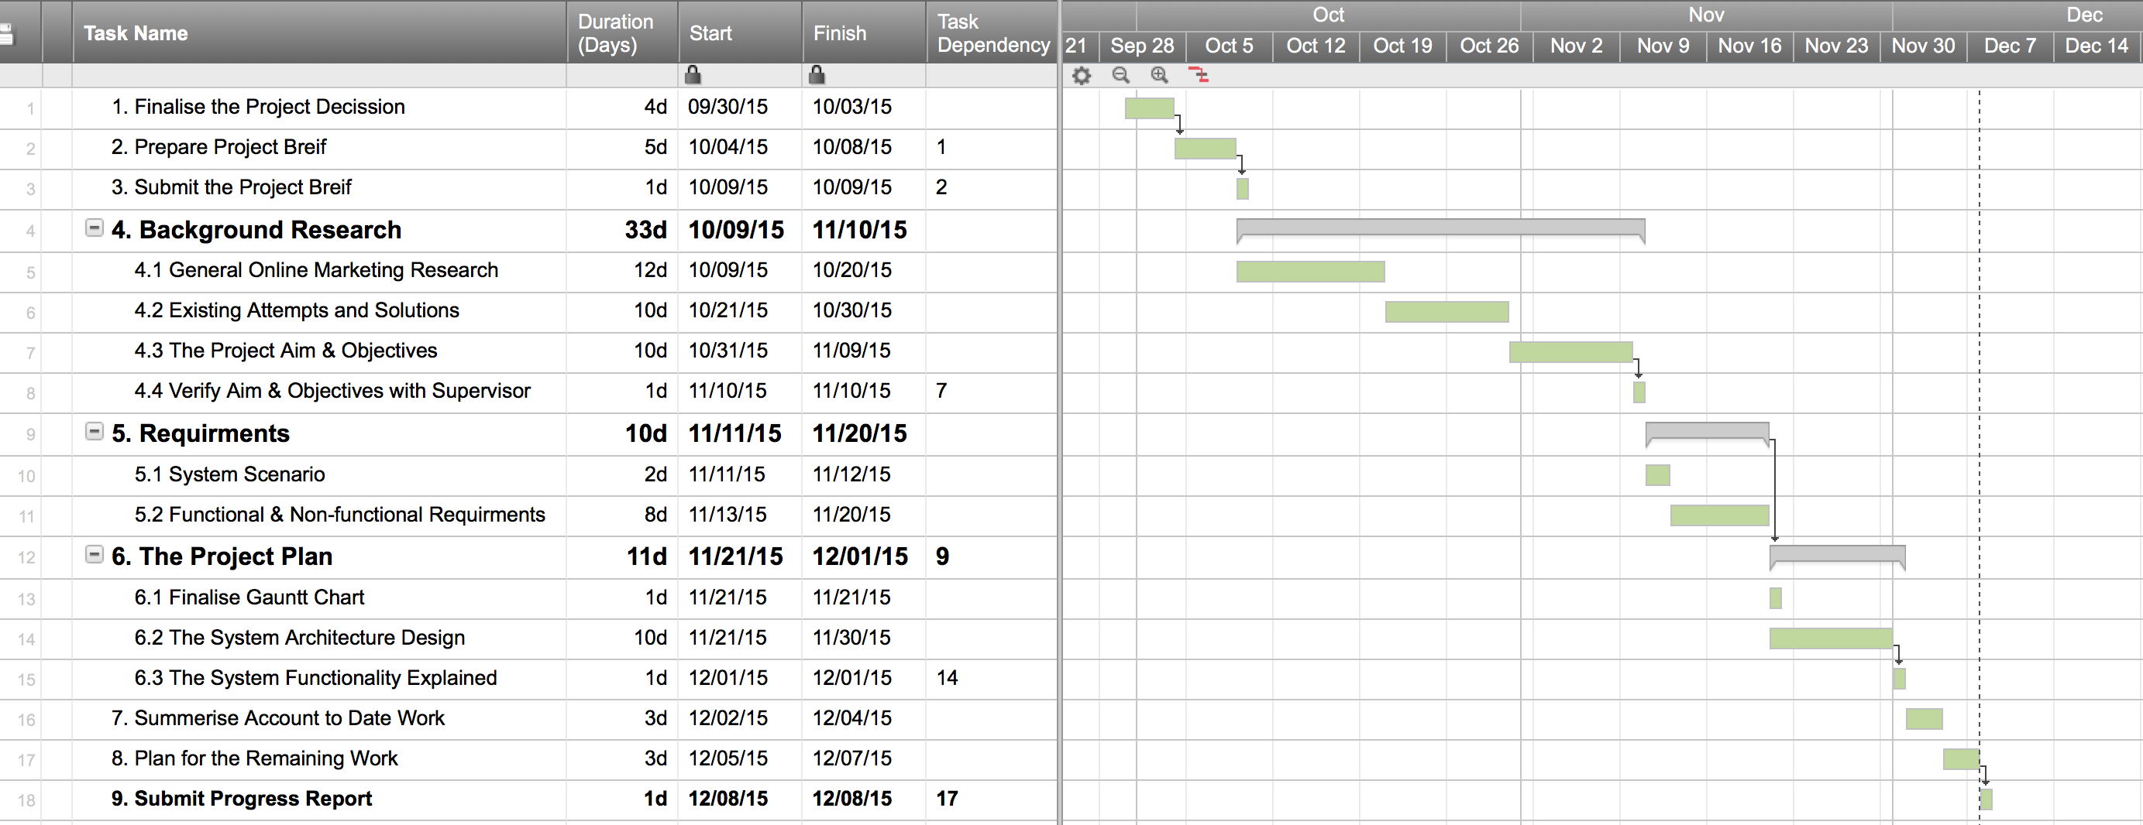**Figure 5** below illustrates the schedule of this project. It represents a list of tasks with its duration in days, and its ‘start date’ & ‘end date’, over the first and second semester. Some tasks have dependency with another task, and it is represented under the column “Task Dependency”. e.g it is compulsory to finish the requirement before starting the project plan. In the right hand side of the chart, each task is also represented graphically, and it shows any dependencies between tasks, with a drop down arrow.

08 Dec

The Gantt chart continues….

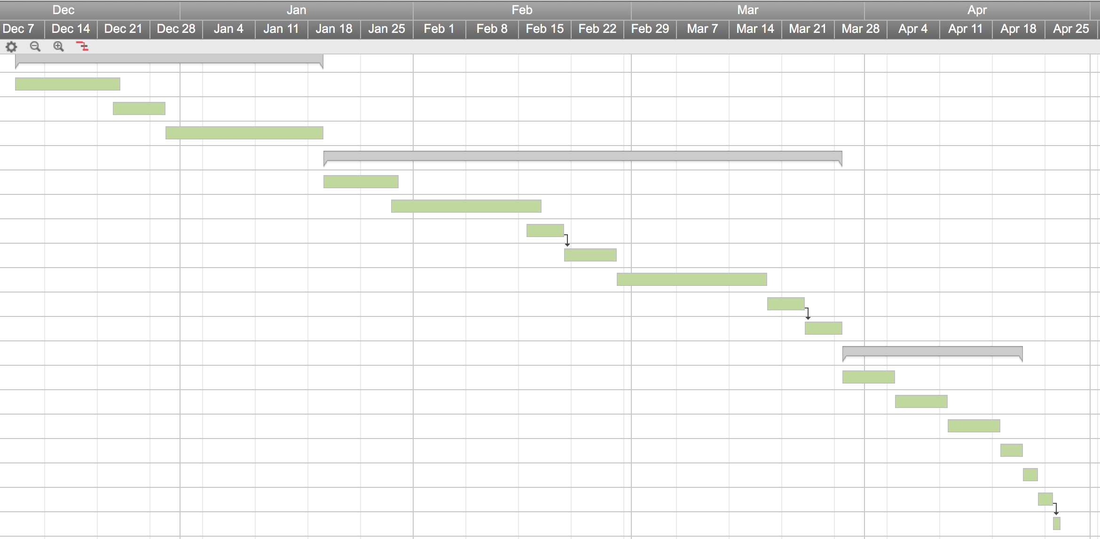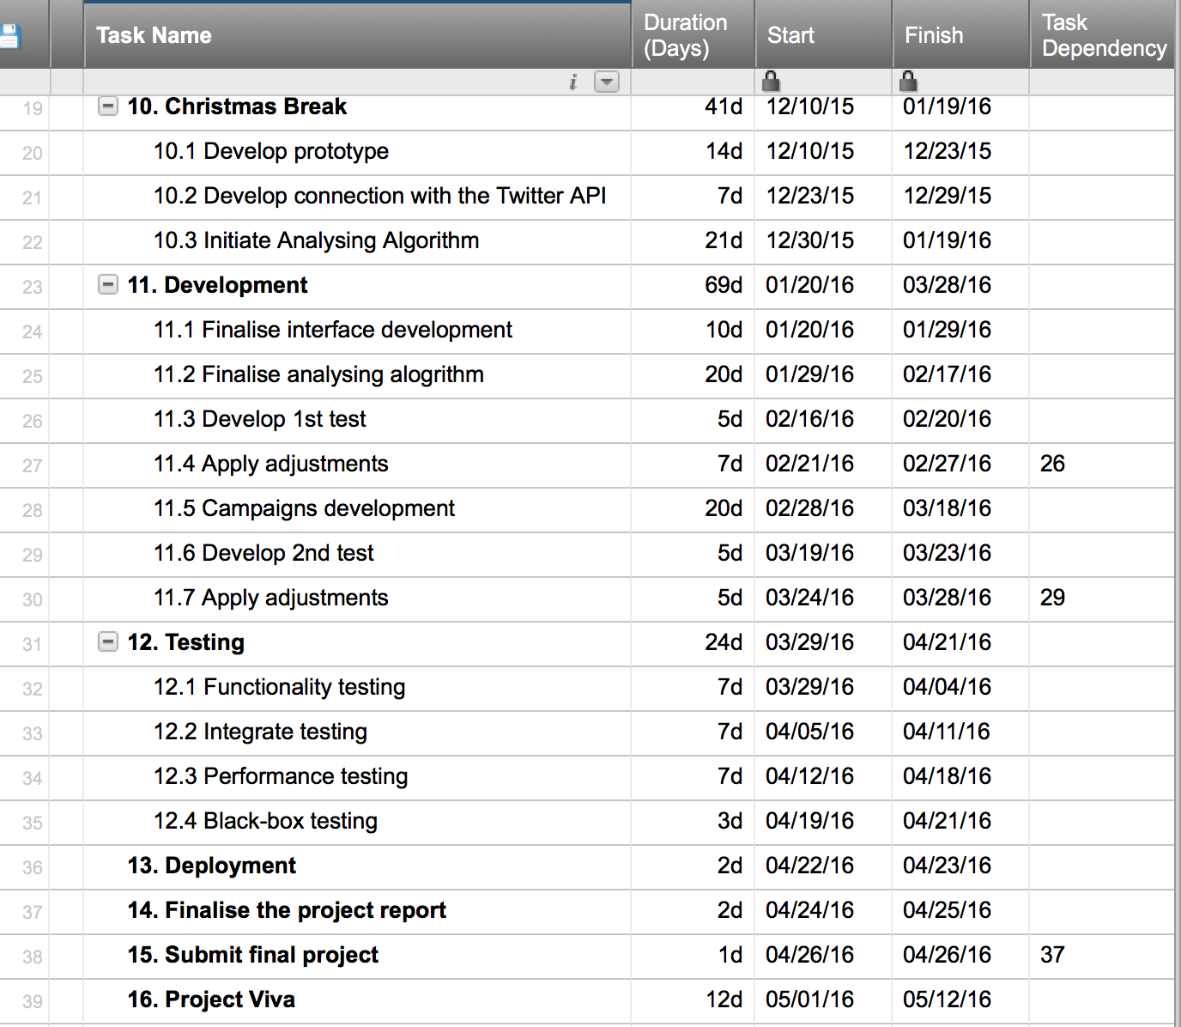

Figure The Project Gantt Chart

## 4.2 Tools Used

Table 5 List of resources used

|  |  |
| --- | --- |
| Resource | Description |
| Software | Software used for this project are Microsoft word for report writing, Sublime Text editor for code writing, SmartSheet used for drawing diagrams & Gantt chart, and Microsoft OneDrive, and DropBox are used for cloud backup. |
| Hardware | Personal laptop mainly used as a hardware resource. A physical external hard drive was also used for daily backup. |
| Reading | The journal articles mainly used for this project are from IEEE Explorer, books were used from Harley Library. Some other sources such as Google Scholar and Delphis were also used for gray literature. |
| People | Five local restaurants owners participated in completing the survey about the use of this system. Classmates, family and friends were also asked for help to proofread the report and give general opinion about the project. |

## 4.3 Programing Languages and Technology Choice

**PHP**

While there are other alternatives web development languages such as Ruby and Python, I chose PHP for handling the sever side functionality of the application. This is because it is simple, and there are many PHP frameworks available, such as CakePHP, which provide the developers the tools to develop an advanced, dynamic and secure web application [20]. PHP is a language that is supported by the Twitter API, this is an advantage because the main part of this system is the ability to communicate with Twitter API and fetch information about the Re-tweeting campaign types.

**Sqlite**

Sqlite is a fast open source database engine that is capable of handling 100,000 requests a day [21]. The reason I chose Sqlite over MySQL is that it is faster and it does not have a separate sever process. Instead it directly reads and writes to the local disk files [22]. This means that I don’t need to use the university server (LinuxProj) or any external servers for accessing and storing data. Sqlite enables me to keep everything local.

Despite all the advantages, Sqlite is not capable of supporting larger databases. This means that when deploying the application to be used in the real world, the database will be much bigger, and there will be a need to migrate to MySQL.

**CakePHP**

To get the application off the ground, there is a need for using a well-structured framework. The framework chosen for the implementing of this application is CakePHP. It simply helps to make initial steps of building the application easy. As the name suggest it is written using PHP programming language. Despite my expertise in PHP we also used CakePHP framework for Cyber Security Module last semester. Therefore having experienced in both PHP language and the framework, it is promising for the success of implementing this application.

CakePHP framework is based on MVC structure, which is typically the separation of the web application operations into specific areas; Model (M) is handling interaction with the database, View (V) displays all outputs to the user, while Controller (C) handles all the commands/scripts that are received as an input [23]. **Figure 6** below shows how MVC 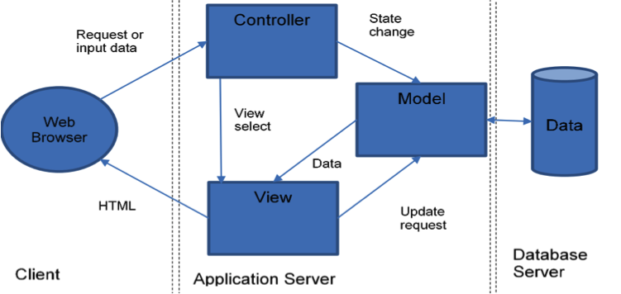structure works together.

Figure 6 MVC Structure Diagram

1. The user makes request via the browser either by clicking an internal link or typing a URL
2. The relevant controller then receives the request, and it process the data attached. The controller will then pass the database request to the model script
3. The model interacts with the database. It may pull data or store data. In either case it updates the controller with the respond from the database
4. The controller then process again the data passed to it by the model, and outputs the results to the view file
5. Finally the view prepare the data to be displayed by adding any design, and then pushing it back to the browser

## 4.4 Back-up and Documentation Plan

The project is stored on my personal laptop using organised file system that splits the project into sections, coding files, submission files (reports), research files, and tables or diagrams used for the project. This system allows me to easily access and amend files. GitHub was also used for coding and report writing management. By frequently deploying changes to the GitHub, it creates a backup list of all versions. This strategy then allowed me to move between different versions of the project, which is really helpful if something goes wrong and there is a need to jump back to previous version. Below is a list of all back-up plans used for the project;

* Microsoft OneDrive
* GitHub
* DropBox
* Personal hard drive
* Personal laptop
* University account

Backups were taken daily and were kept consistent into both cloud and physical storage.

## 5. Design

5.1 System Architecture

**Figure 7** below illustrates the core architecture functionality design of the system, by using Christmas campaign as an example. It will explain how the system interconnected and how it functions.

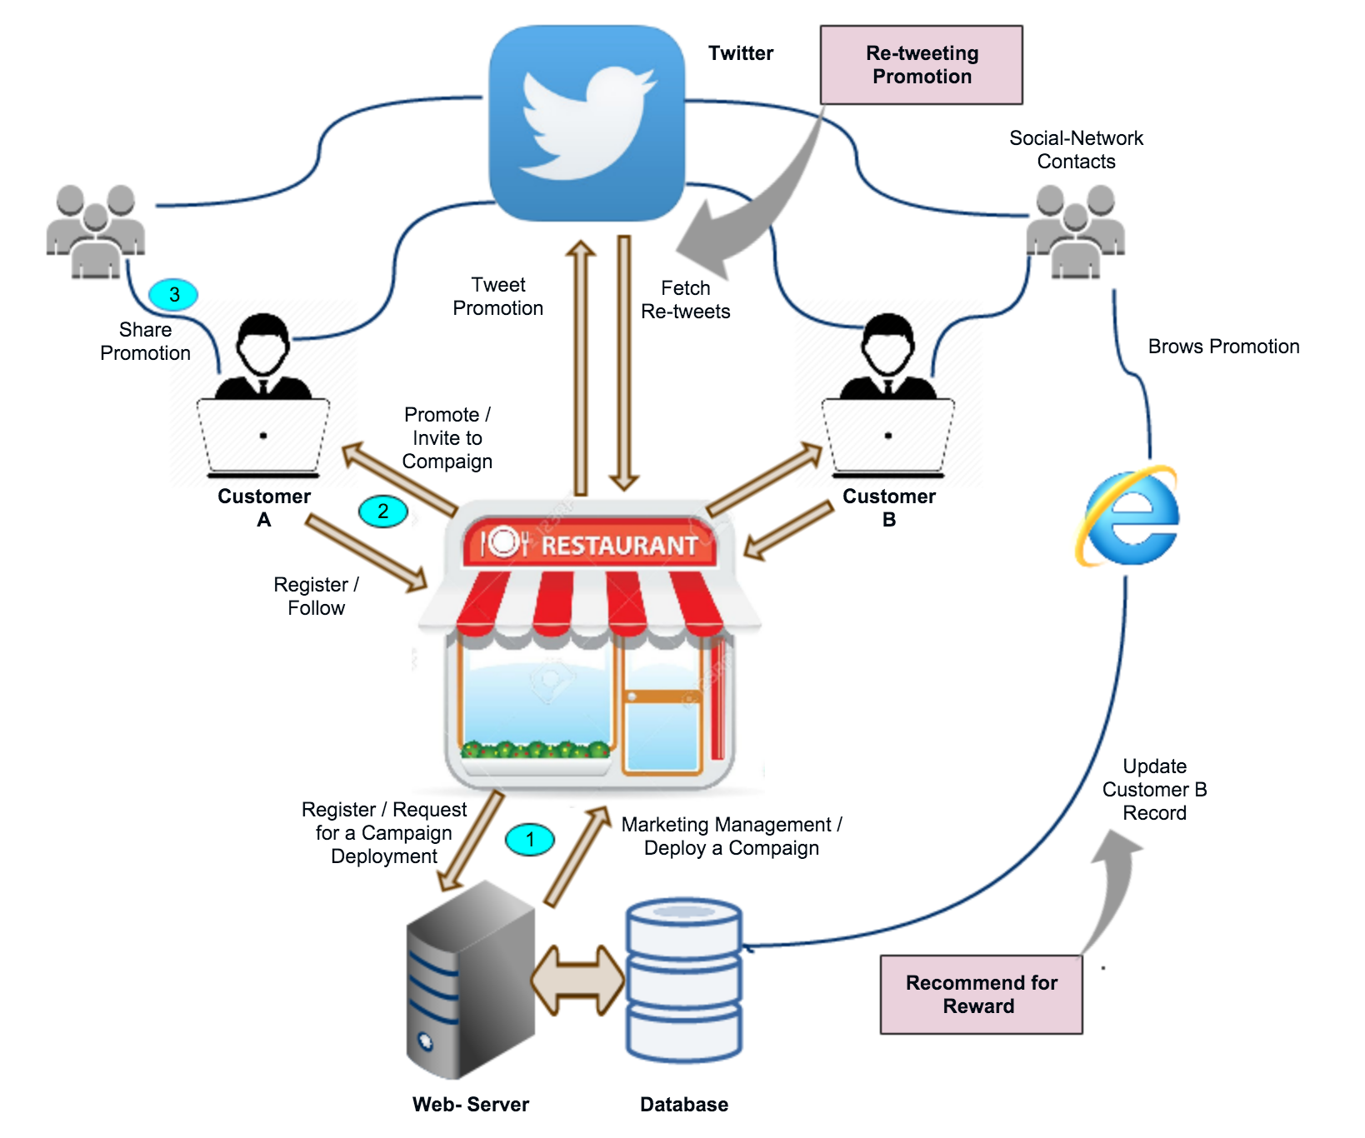

Figure 7 The System Architecture Design

## 5.2 Campaign Walkthrough

Assuming that at least one restaurant is registered with the system, and a few customers are following or registered within the restaurant website. The Christmas campaign is a Re-tweeting campaign that is either requested by the restaurant to be created or recommended by marketing management team to the restaurant and they have to confirm that, by providing some of the parameters needed to create the campaign, such as; start date and end date, the campaign hashtag, a set of offers to be promoted in the campaign, and the prizes for the winners. For this illustrative campaign, these are:

Restaurant: British Dining

Campaign Type: Retweet Competition (winner is the person who gets most re-tweets for the restaurant)

Campaign Title: Christmas Campaign

Start: 1/12/2015, End: 25/12/2015

Hashtag: #ChristmasSurprise

Offers: 30% off Christmas menu for students

Prize: Free Christmas dinner for winner

After the parameters are set, the campaign gets launched to the customers as illustrated in **step one** of the design, the customers will share the campaign with their friends and family, as shown in **step three** of the design. As the campaign gets shared and re-tweeted by more and more people the marketing management team will monitor and analyse its performance, and the information will be shared with the relevant restaurant for which the campaign is held. After the deadline the marketing system will summarise the result and calculate the winners. The winners will be notified by email and it will be shared among other users in the network to motivate them for participating in the next campaign. The users who responded to the campaign will now know about the particular restaurant and they might visit the restaurant and register as a new customer. Hence it will result in network growth.

## 5.3 Major Platform Functions

*Restaurant Registration:* store all restaurant details in database; choose standard website template and fill in details; create empty database of restaurant customers.

*Customer Registration:* store all customer details in database including address info, demographic info, payment details, social media ids for Twitter, Facebook etc.

*Campaign Management:* create campaign, edit campaign, start campaign, report on campaign progress, halt campaign.

*Social Media Management:* send message to customers of restaurant, monitor mentions of restaurant, monitor mentions of campaign hashtags.

## 5.4 The System Wireframe

Dashboard

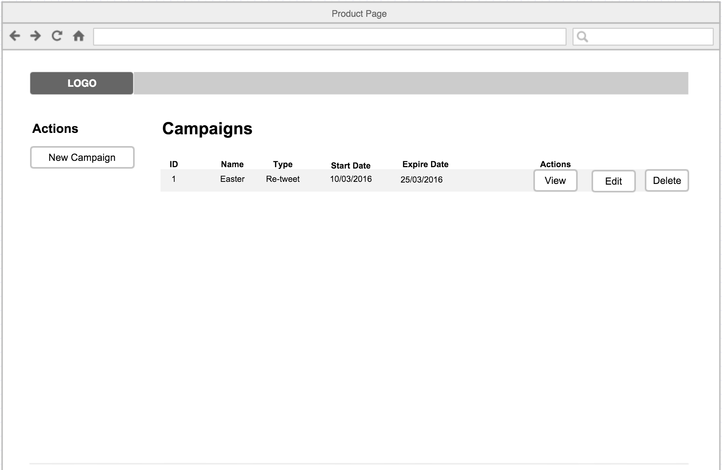

Figure 8 Dashboard Wireframe

The wireframe on **figure 8** shows the dashboard of the British Dining Promoting system used by the restaurants. Although the full system-design require many wireframes, but to summarise the design I have only included the dashboard, because it is the main base, and every other actions branches from here. For example after login, the user will be directed straight to the dashboard where all the currently running campaigns are listed. The campaign actions let you view, delete or edit it. A link is also provided for creating a new campaign.

This wireframe design helps to get started with the first cycle of implementation phase. It clarifies how the first prototype should look like.

5.5 Database Design

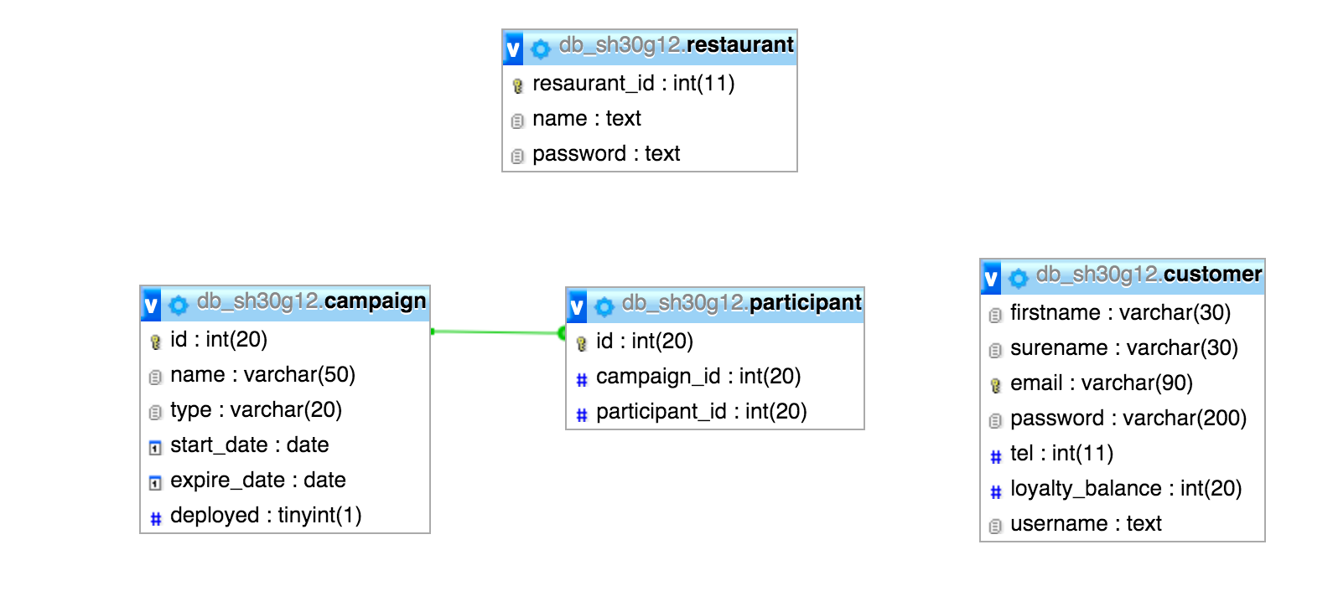

Figure 9 The Database Design

The main purpose of the database design is to minimise the redundancy and dependency, as well as insuring high integrity of data. To achieve this, the 1st, 2nd, 3rd normal forms are carried out, which helps to easily fetch data from the database by splitting the data into a number of logical related unites, that are linked with defined relationships [17]. **Figure 9** illustrates the structure of the database schema for the system. At the initial design, the participant table didn’t exist, and the campaign table was directly connected to the customer table. However it was noticed that when fetching the participants directly from the customer table all users gets listed, even those customer who didn’t participant in the campaign. Therefore a separate table (participant) was created to store the user id of all participants for individual campaigns.

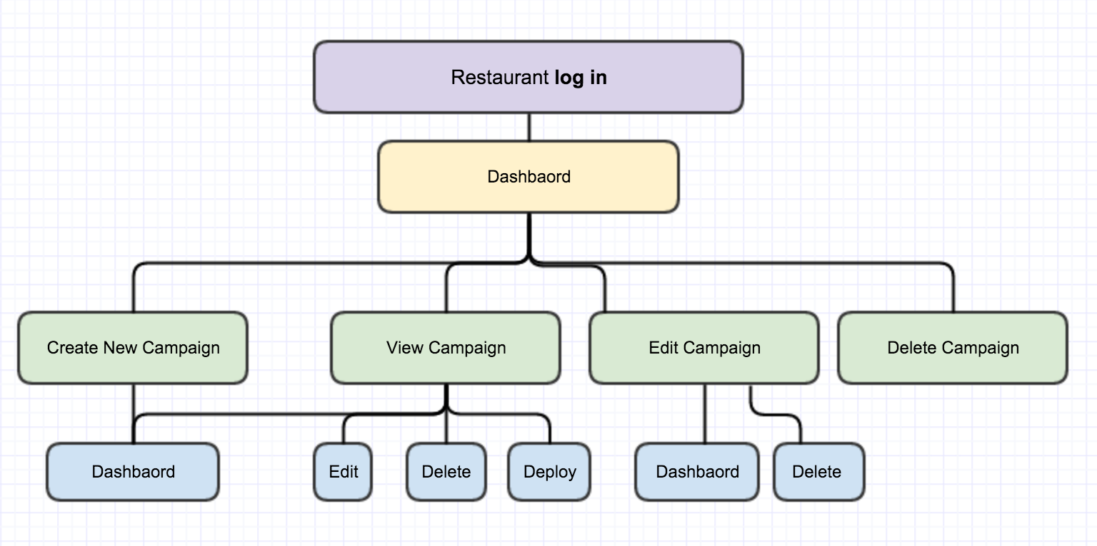

5.6 PHP Mapping

The diagram on **figure 10** is a PHP mapping that illustrates how different pages and core functionality of the system will be interconnected together to enable the user to navigate around, and perform certain actions.

Figure 10 PHP Mapping Diagram

# 6. Implementation

As illustrated in the Gantt chart, this phase of the development consists of several implementing iterations. In the first iteration I will implement a prototype that reflect the design phase of the software development. In the second one I will discuss the improvements need to be made, and discuss the methods to be used for adding extra functionality. In the third iteration, the implementation will be finalised. Challenges and problems will be discussed as well as alternative solutions.

## 6.1 First Iteration

In the first cycle of implementation, the following tasks are completed as showed in **Table 6** in order to develop an initial prototype of the system.

Table 6 lists of task completed in the first implementation cycle

|  |  |  |
| --- | --- | --- |
| Status | Task | Priority |
| Macintosh HD:Users:Saber:Desktop:OneDrive:Documents:Information Technology in Organisation Year3:Part III Individual Project:images used:big-tick.jpg | Construct an SQLite database scheme based on the database design with the following tables: restaurant, campaign, customer, and participant. With the aid of normalization, I split them into logical units and defined relationships between them. E.g. campaign table have one-to-many relationship with the participant table. | Vital |
| Macintosh HD:Users:Saber:Desktop:OneDrive:Documents:Information Technology in Organisation Year3:Part III Individual Project:images used:big-tick.jpg | Downloaded the CakePHP framework template, rendered the database configuration and tested, to make sure that the database is connected successfully. Of all PHP frameworks I chose CakePHP because we have been using it in the Cyber Security module, and it is proven to be very secure, maintainable and efficient way of development web applications. | Vital |
| Macintosh HD:Users:Saber:Desktop:OneDrive:Documents:Information Technology in Organisation Year3:Part III Individual Project:images used:big-tick.jpg | Using the CakePHP ‘bake’ command I generated the Model, Controller, and View pages for the system. | Vital |
| Macintosh HD:Users:Saber:Desktop:OneDrive:Documents:Information Technology in Organisation Year3:Part III Individual Project:images used:big-tick.jpg | Implemented a login page, so that the users (restaurants) can login into the system using their restaurant ID and password. Also implemented a link so that the users can logout after login. | Vital |
| Macintosh HD:Users:Saber:Desktop:OneDrive:Documents:Information Technology in Organisation Year3:Part III Individual Project:images used:big-tick.jpg | Created a CSS custom style page in order to present the information in the login page and other pages appropriately, taking into account the usability and accessibility. | Necessary |

After all the tasks were successfully completed, the system initial prototype was formed. Now the user can login. After the authentication has passed, the user will be directed to the dashboard where all the campaigns are held. At this point the user can run operations such as view, add and delete campaigns. However at this stage a campaign is not more than just a record in the database. It is not distributable, it is not linked to a content page, and it has no participants. All of these functionalities are to be implemented in the next iteration. For full information and screenshots about the first iteration please see **appendix 2**.

Table 7 The project progress after 1st iteration, based on the user requirements

|  |  |  |
| --- | --- | --- |
| Key | Description | Progress |
| F1 | Log in | 100% |
| F2 | Log out | 100% |
| F3 | Change Password | 0% |
| F4 | Create a Recommend for Reward campaign | 35% |
| F5 | Create a Re-tweeting social media campaign | 10% |
| F6 | Deploy the campaign | 0% |
| F7 | View statistical information about the current state of a campaign | 0% |
| F8 | Edit the campaign | 80% |
| F9 | Delete the campaign | 100% |
| F10 | Analyse and calculate the campaign results | 0% |
| F11 | Calculate the prize | 0% |
| F12 | Perform analysis on customer’s social media activities, and promote relevant products to them vie email. | 0% |
| F13 | Auto promotions distribution to hundreds of customers by email | 0% |
| F14 | Users should be able to unsubscribe from the promotion emails | 0% |

## Table 7 is a copy of the functional requirements list. During the first iteration some of these requirements were fully implemented and some are to be completed during second and third iterations. The progress column shows graphically the state of each requirement using the progress bar, and percentage.

## 6.1.1 Problems and Challenges

Getting started to build the application using the CakePHP framework was a challenging task, because as well as it being helpful by providing numerous functionality such as bake, and Authentication, it also force the developer to follow their principle. For example I had to rename the restaurant table to ‘user’ in order for the authentication to function normally.

While implementing the login, I encountered an authentication problem. Even in case of providing the right restaurant ID and password, the server failed to authenticate the user. I was using the CakePHP Auth functionality for authenticating the user, therefore for some reason the framework could not validated the login request. By doing some research I found that with the use of CakePHP the table in the database used for storing the login credential has to be named ‘user’, in order for the login process to function as expected. Therefore I was been forced to modify the restaurant table in the database and renamed it to ‘user’. Having done that I managed to solve the problem.

## 6.2 Second Iteration

While the previous cycle of implementation was all about constructing an initial prototype for the system, this iteration is focused on advancing the core functionality of the application in order to best meet the requirements. One of the main goal is to enable the users (restaurants) to create a campaign content page for each campaign that is created, and also providing the tools to design the content page within the browser, just like it is done in the paint program. **Table 8** shows a list of functionalities added to the application. Please see **appendix 3** for more details and screenshots.

Table 8 Lists of features implemented in the second iteration

|  |  |  |
| --- | --- | --- |
| Status | Task | Priority |
| Macintosh HD:Users:Saber:Desktop:OneDrive:Documents:Information Technology in Organisation Year3:Part III Individual Project:images used:big-tick.jpg | Modify the add function in the campaign controller file so that, a content page is created, and named with the ID of the current campaign, so that each content page is linked with the right campaign. When the campaign is deployed it is the content page that is viewed by the participant. Hence it is an advert to promote the restaurant.  Macintosh HD:Users:Saber:Dropbox:Screenshots:Screenshot 2016-03-23 23.31.25.png | Vital |
| Macintosh HD:Users:Saber:Desktop:OneDrive:Documents:Information Technology in Organisation Year3:Part III Individual Project:images used:big-tick.jpg | Install and adopt the TinyMCE plugins to provide the user with the tools to design and add contents such as media (image, and video) files to the content page directly from the browser, just like designing a page in paint.  Macintosh HD:Users:Saber:Dropbox:Screenshots:Screenshot 2016-03-23 23.33.48.png | Vital |

Table 8 continues…

|  |  |  |
| --- | --- | --- |
| Macintosh HD:Users:Saber:Desktop:OneDrive:Documents:Information Technology in Organisation Year3:Part III Individual Project:images used:big-tick.jpg | Implement a ‘deploy’ function, so that the campaign can be launched by the restaurant, to all of its registered customers, using SMTP email protocol.  Macintosh HD:Users:Saber:Dropbox:Screenshots:Screenshot 2016-03-23 23.40.49.png | Vital |
| Macintosh HD:Users:Saber:Desktop:OneDrive:Documents:Information Technology in Organisation Year3:Part III Individual Project:images used:big-tick.jpg | Modify the view function of the campaign controller file so that it lists all the participants for that particular campaign, when the restaurant views it. Only the restaurants will have access to this function by login to the system using their restaurant ID and password. Note that this is different to viewing the campaign’s content page that is accessed publicly by the participant (the restaurant customers). | Vital |
| Macintosh HD:Users:Saber:Desktop:OneDrive:Documents:Information Technology in Organisation Year3:Part III Individual Project:images used:big-tick.jpg | Amend the display function so that every time the campaign’s content page is loaded it signals the database and increases the loyalty balance of relevant customer. For example if Bob recommends the Christmas campaign to his friend Fred, when Fred clicks the link and load the campaign’s content page, Bob’s loyalty balance will be updated. | Vital |
| Macintosh HD:Users:Saber:Desktop:OneDrive:Documents:Information Technology in Organisation Year3:Part III Individual Project:images used:big-tick.jpg | Using FlipClock plugin to calculate the time difference between current date and the campaigns expire date, and display the result as a countdown timer when the campaigns is viewed. | Necessary |

# After advancing the initial prototype in the second cycle of implementation, now the campaigns are distributable after being created. At this point, a campaign that is created by the user (restaurant) is not only a record in the database, but it also holds a content page linked to it, which is the promotion that gets viewed by the campaign’s participants. Time left to expire and list participants are showed when viewing the campaign. Although the application being improved, however it still doesn’t have capability to interact with the Twitter API. Therefore the Re-tweeting campaign type is not complete, and the user is not able to deploy a campaign on Twitter as well as tracking its performance.

Table 9 The project progress after 2nd iteration, based on the user requirements

|  |  |  |
| --- | --- | --- |
| Key | Description | Progress |
| F1 | Log in | 100% |
| F2 | Log out | 100% |
| F3 | Change Password | 0% |
| F4 | Create a Recommend for Reward campaign | 100% |
| F5 | Create a Re-tweeting social media campaign | 20% |
| F6 | Deploy the campaign | 100% |
| F7 | View statistical information about the current state of a campaign | 40% |
| F8 | Edit the campaign | 100% |
| F9 | Delete the campaign | 100% |
| F10 | Analyse and calculate the campaign results | 40% |
| F11 | Calculate the prize | 40% |
| F12 | Perform analysis on customer’s social media activities, and promote relevant products to them vie email. | 0% |
| F13 | Auto promotions distribution to hundreds of customers by email | 0% |
| F14 | Users should be able to unsubscribe from the promotion emails | 0% |

Looking at project progress in **Table 9,** most of the requirements were met. Interacting with the Twitter is the main improvements to be made in the next cycle of implementation.

## 6.2.1 Problems and Challenges

The most challenging task in this cycle of implementation was finding a plugin to provide the user with the toolbox to design and edit the campaigns content page in the browser. I managed to embed a designing toolbox (TinyMC) into the content text area, however the problem was that after saving the changes only the contents gets saved but not the design. For example when making the heading bold and centered, after saving the changes the styling used to not get saved with the text and the heading appeared just as a normal text when viewing the content page. After researching the problem for a day, I discovered that it is not compatible with the framework I am using, therefore to make it work, a special version of TinyMC plugin needs to be used. After installing the compatible version I managed to solve the problem.

I also faced a security problem. While the purpose of Recommend for Reward campaign is receiving loyalty credit for sharing the campaign with each member of their family or friends, the participants could cheat the system and increase their loyalty balance infinitely by keeping on refreshing the campaign page. To overcome this problem there was a need for a security layer in the application to detect that it is the first time the campaign content page being loaded by each person, and that person is not the recommender himself. Therefore I stored a cookie and recorded the IP address of each person loading the campaign’s content page for the first time. This make sure that if they load the page for second time they are known to the system, and therefore the recommender’s loyalty balance doesn’t get updated.

## 6.3 Third Iteration

## This is the final implementation cycle, and it is mainly concerned with creating a communication stream with the Twitter API in order to enable the user to deploy a Re-tweeting campaign, and track its performance. It means when viewing the Re-tweeting campaign not only the participants would be listed, but I will also advance the system to show the five top tweets that have currently received the highest number of re-tweets. I will also add the functionality of calculating the winner for the Re-tweeting campaign. This function will be triggered a second after expiration of the campaign, and of course the winner will be the customer who received the highest number of re-tweets by sharing the campaign on Twitter. Table 10 shows a list of tasks completed during the final cycle of implementation.

Table 10 Lists of features implemented in the third iteration

|  |  |  |
| --- | --- | --- |
| Status | Task | Priority |
| Macintosh HD:Users:Saber:Desktop:OneDrive:Documents:Information Technology in Organisation Year3:Part III Individual Project:images used:big-tick.jpg | Alter the “create” function of the campaign to NOT create a content page for Re-tweeting campaign type, but rather store the contents in the database. When deploying the campaign, the contents will be fetched back from the database and emailed to all customers. They will then follow the instructions to tweet the campaign with relevant promotion message and the #Hashtag. | Vital |
| Macintosh HD:Users:Saber:Desktop:OneDrive:Documents:Information Technology in Organisation Year3:Part III Individual Project:images used:big-tick.jpg | Use the #Hashtag as a parameter to query the Twitter API, and fetch the latest information about the campaign. | Vital |
| Macintosh HD:Users:Saber:Desktop:OneDrive:Documents:Information Technology in Organisation Year3:Part III Individual Project:images used:big-tick.jpg | Alter the “view” function to show five campaign tweets with the highest number of re-tweets. | Vital |
| Macintosh HD:Users:Saber:Desktop:OneDrive:Documents:Information Technology in Organisation Year3:Part III Individual Project:images used:big-tick.jpg | Add functionality to calculate the campaign winner. | Vital |
| Macintosh HD:Users:Saber:Desktop:OneDrive:Documents:Information Technology in Organisation Year3:Part III Individual Project:images used:big-tick.jpg | Handle accessibility of the campaign when it expires. | Necessary |

## With the implementation phase finalised, now the application is capable of creating and deploying two types of campaigns, as well as managing them, and monitoring their performance.

Table 11 The progress summary after the final iteration

|  |  |  |
| --- | --- | --- |
| Key | Description | Progress |
| F1 | Log in | 100% |
| F2 | Log out | 100% |
| F3 | Change Password | 100% |
| F4 | Create a Recommend for Reward campaign | 100% |
| F5 | Create a Re-tweeting social media campaign | 100% |
| F6 | Deploy the campaign | 100% |
| F7 | View statistical information about the current state of a campaign | 100% |
| F8 | Edit the campaign | 100% |
| F9 | Delete the campaign | 100% |
| F10 | Analyse and calculate the campaign results | 100% |
| F11 | Calculate the winner | 100% |
| F12 | Perform analysis on customer’s social media activities, and promote relevant products to them vie email. | 0% |
| F13 | Auto promotions distribution to hundreds of customers by email | 0% |
| F14 | Users should be able to unsubscribe from the promotion emails | 0% |

## Although the implementation phase is finalised, a few requirements were not completed as shown in Table 11. These requirements are related to personalised promotion side of the application, as explained in the project goals, and they will be considered as future improvement for the system.

## 6.3.1 Problems and Challenges

## In the final round of implementation the most challenging task was authenticating access to the Twitter API. Combinations of four keys (Consumer key, Consumer secret, Access token, and Access secret) were required to generate an Authentication Signature. Doing this for every request was an exhausting task, and it also didn’t work sometimes. After doing some research I discovered that by downloading ‘Twit’ plugin, POST and GET requests can be made easily. I only needed to provide the keys once in the parameter, and make unlimited queries to the API.

## 6.4 System Security

One of the biggest challenges for a web application is security, which refers to threats that occurs due to mistakes during the software development life cycle [24]. Having studied Cyber Security last semester, I have realised the importance of security in a web application. Therefore this system was implemented with a high level of security.

**6.4.1 SQL Injection**

## This application was developed with the CakePHP framework. Therefore it handles all the queries to the database. This insures good protection against SQL injection threat because CakePHP is a very reliable in terms of handling database queries.

**6.4.2 Password Protection**

Raw passwords are not stored in the database. They are first hashed using Blowfish password hasher, and only the encrypted version gets stored. This method provides high level of protect against the password hackers.

**6.4.3 Preventing Customers to Cheat**

After implementing the campaign content page, the campaign recommenders could increase their loyalty balance by keeping on refreshing the content page. To overcome this problem I stored a cookie and recorded the user’s IP address when visiting the content page. This makes sure that the recommender is only rewarded for new visitors to the campaign promotion.

**6.4.4 Other Web Vulnerabilities**

Other threats to the web application such as: Cross Site Request Forgery, Authorisation Bypass, Parameter Manipulation, Insecure Cookies, and Brute Force, are well handled by the CakePHP framework library.

7. Testing

## In this chapter the application is put under a variety of different testing strategies, in order to measure its performance against expected out comes, and its original requirements [25]. The common process for all tests will be running each function, reports its performance, Fix it, and re-run the test. Figure 11 is a testing activity diagram that illustrates this process.

## Macintosh HD:Users:Saber:Desktop:OneDrive:Documents:Information Technology in Organisation Year3:Part III Individual Project:images used:Android Testing Activity Diagram.jpg

Figure 11 Testing Activity Diagram

## 7.1 Testing Strategies

## Considering the type and size of this project, the most suitable test are; Black Box testing, Unit testing / White Box testing, and Compatibility testing. Black box testing involves testing each functionality of the application without looking at the code. One of the advantages it has over the other methods is that it doesn’t necessary needs to be performed by the application implementer, because there is no need for implementation knowledge [26]. On the other hand, Unit testing is to do with testing the internal code of an application. It is important for validating the implementation phase and revealing bugs in the code [27].

## 7.2 Unit Testing

The CakePHP unit testing was used to write test cases for all Model, Controller, and View files and functions in the application. The implemented tests classes and methods contain solid code that calls every function in the application e.g deploy function, and compares its outcome with an expected value or action. The result of this comparison then reports its success or failure. **Figure 12** shows the result of testing the campaign model. See **Table 12** for full list of unit tests.

## Macintosh HD:Users:Saber:Dropbox:Screenshots:Screenshot 2016-03-31 19.51.43.png

Figure 12 Campaign Model Unit Test

## Figure 12 is the result of testing the Campaign Model, it is reported that all functions in that class are behaving as expected, which means it passed the test.

Table 12 PHP Unit test cases

|  |  |  |  |
| --- | --- | --- | --- |
| Function Tested | Description | Expected Result | Test Result |
| Login | Comparing the returned value of login in case of providing correct credentials | Return ‘True’ | Pass |
| Login | In case of incorrect credentials | Return ‘False’ | Pass |
| Add | The test creates a campaign by calling the add method and access the database to check if the campaign has been added. Also checks if the content page was created. | Return ‘True’ | Pass |
| Deploy | Deploy the campaign and check if sending emails to the participants are acknowledged by the SMTP mail server | Return ‘True’ | Fail  (The function amended and tested again) |
| Edit | Call the edit method and access the database to confirm the updated details | Return ‘True’ | Pass |
| Delete | Call the delete method and access the database to check if it still exists | Return ‘False’ | Pass |
| View | The test accesses the Twitter API by calling the view function, and checks if the access being granted. It also checks if other details are fetched from the database. | Return ‘Successful’ | Pass |
| Display | The display function display the campaign content page, and create a cookie (Visited). The test checks existence of the cookie, after calling the function. | Return ‘True’ | Fail (The function amended, and tested again) |

According to **Table 12** most of the functions passed the test, however only two functions failed. I amended the ‘deploy’ function so that the send acknowledgement of every email gets recorded in an array. While testing the method again, I looped the array, and checked if each email has been successfully sent. The other failure function is ‘display’. For amending this function I looked at the CakePHP documentation, and used the cookie class provided by the framework. After changing the method, it has been tested again. **Figure 13** shows a list of functions that have been tested for the second time.

Table 13 CakePHP Second Round Unit Test

|  |  |  |  |
| --- | --- | --- | --- |
| Function Tested | Description | Expected Result | Test Result |
| Deploy | Deploy the campaign and check if sending emails to the participants are acknowledged by the SMTP mail server | Return ‘True’ | Pass |
| Display | The display function display the campaign content page, and create a cookie (Visited). The test checks existence of the cookie after calling the function. | Return ‘True’ | Pass |

## 7.2.1 JS Hint Code Test

JS Hint is a software application that takes JavaScript code as input and tests the code line by line. When the testing finish it then reports summary of the results, listing all the bugs found in the code. For testing the JavaScript files in the application, I have used JS Hint. This insures that the files are well structured and bug free. **Figure 13** is a screen shot of the JS Hint test result.

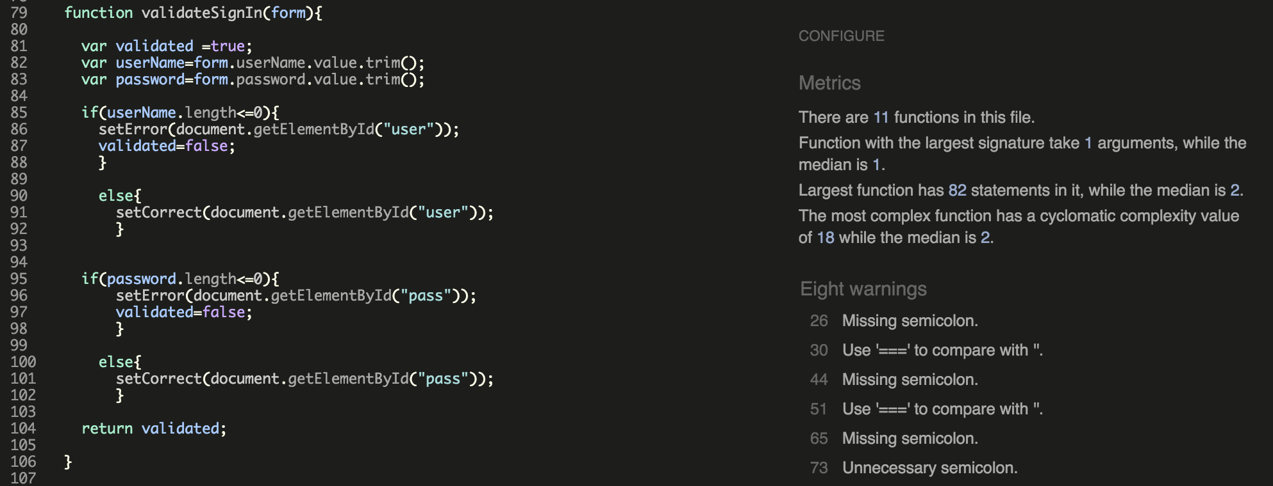

Figure 13 JS Hint test report

There have been eight bugs found in the code. The line number addresses each error, this makes it easy to navigate through the code and fix it. After fixing all the bugs, the code has been put into test again. **Figure 14** shows the new results.

## Macintosh HD:Users:Saber:Dropbox:Screenshots:Screenshot 2016-03-31 23.22.04.png

Figure 14 JS Hint Second Round Test

## The revised test result on Figure 14 confirms the application’s JavaScript files are now free of errors.

## 7.3 Black-Box Testing

This testing is more user based, therefore I asked my cousin Kawani to voluntarily run the black box testing, and monitor the outcome, to see if it matches what he expects from the application. **Table 14** shows the full list of functionalities tested.

Table 14 Black box testing

|  |  |  |  |
| --- | --- | --- | --- |
| Test Name | Description | Expected outcome | Actual outcome |
| Login | Login with the correct credentials | Redirect the user to the dashboard | Pass |
| Login | Login with the wrong credentials | Display error message (invalid username or pass) | Pass |
| Access pages before login | Access the dashboard and other campaign pages prior to the login. | Redirect back to login page, displaying the unauthorised error message. | Pass |
| Add a campaign | Submitting an empty form for creating a new campaign | Redirect back to add page, notifying the user about the empty input fields. | Fail |
| Add a campaign | Create a campaign by providing the required information | Create the a new record in the database campaign table | Pass |
| Add a campaign | Add a campaign with expire date and start date in the past | Display error message notifying the user to provide a date in the future | Fail |
| Delete | Delete a campaign before it is deployed | Remove the campaign from the database | Pass |
| Delete | Delete a campaign after deployment, and before it expires | Display an error, notifying the user that the campaign is currently running and its only removable after it expires. | Fail |
| Delete | Delete an expired campaign | Remove the campaign from the database | Pass |
| Edit | Edit the campaign details, changing the expire date to a date in the past | Display an error message notifying about the invalid date entry | Fail |
| Design | Design the content page in the browser, with the tools provided | The design and style should reflect when viewing the content page. | Pass |
| Delete the content page | Delete the campaign content page, by deleting the campaign itself | Content page not accessible after the campaign being deleted | Pass |
| Deploy | Deploy the campaign by clicking the deploy button | All customers in the database receive an email about the campaign | Pass |
| Deploy | Deploy a campaign that is already been deployed | Display an error message notifying the user that the campaign is already deployed | Pass |
| Receive reward | View the campaign content page to check if the recommender’s loyalty balance increases. | Update the loyalty balance field in the customer table | Pass |
| Cheating Security | Re-load the content page to check if the recommender’s loyalty balance increases again | Loyalty balance not updated, as the cookie stored in the browser confirms that the page has been visited before | Pass |
| View | View the campaign | Show the campaign details including the count down timer, list of participant, and the list of five Tweets with the highest number of Re-tweets | Pass |
| Announce the winner | After the campaign expiration, announce the winner | The participant with the highest number of re-tweets r should be chosen to be the winner | Pass |
| Logout | Logout from the system by clicking the logout button | Lock all the pages and redirect user to the login page, notifying successfully logout. | Pass |

Following the failed tests, improvements have been applied, and the unsuccessful functions have been put into test again. **Table 15** shows the revised test results.

Table 15 Revised test

|  |  |  |  |
| --- | --- | --- | --- |
| Test Name | Description | Expected outcome | Actual outcome |
| Add a campaign | Submitting an empty form for creating new campaign | Redirect back to add page notifying the user about the empty input fields. | Pass |
| Add a campaign | Add a campaign with expire date and start date in the past | Display error message notifying the user to provide a date in the future | Pass |
| Delete | Delete a campaign after deployment, and before it expires | Display an error, notifying the user that the campaign is currently running and its only removable after it expires. | Pass |
| Edit | Edit the campaign details, changing the expire date to a date in the past | Display an error message notifying about the invalid date entry | Pass |

## 7.4 Compatibility Test

## During the implementation, Firefox was the only browser used for navigating through the application. In this section of the report the application is put into test, to examine how contents are displayed in all todays modern browsers, as well as in different hardware platforms such as desktop, laptop, tablet, and mobile phone. Table 16 shows the result of this test.

Table 16 Compatibility Test

|  |  |  |
| --- | --- | --- |
| Browser / Platform | Version / Type | Test Result |
| Google Chrome | 49.0.2623.87 | Pass |
| Mozilla Firefox | 45.0.1 | Pass |
| Internet Explorer | 11 | Pass |
| Safari | 9.1 | Pass |
| Opera | 36 | Pass |
| Desktop | Mac, Windows | Pass |
| Laptop | Mac, Windows | Pass |
| Tablet | iPad, Windows Tablet | Pass |
| Mobile | iPhone, Android | Fail |

## Although the application proves to be compatible with almost all browsers and platforms, however the last test failed. Having run the application on mobile phone, the content were displayed out of margin, and it was hard to navigate. Therefore it failed to meet the accessibility requirement with the mobile phone. This problem was fixed by the use of Bootstrap responsive design. The test process revised and the results were Pass.

## 8. Evaluation

## In this chapter of the report the application is weighted against it its initial requirements and goals. After having finalised the implementation and testing the application to make sure all the functions are performing as expected, now the project has reached the stage to meet its real users for the first time. An evaluation study was conducted to examine the usefulness of the system, and to conclude whether the system has accomplished its mission.

## 8.1 Evaluation Approach

The main aim of performing an evaluation study is to understand usability and effectiveness of the system to local restaurants. To gather required information that helps making this decision, I held a survey about the system that is completed voluntarily by five local restaurants. Because of the project scope being relatively small, only five participants are chosen for taking part in the evaluation phase. According to research on similar projects, it has been said that, best outcome on evaluation study comes from involving no more than five participants [28]. The survey questionnaire consisted of four questions that are listed bellow; **See Appendix 4 for full format of the survey.**

1. What online promotions system are you using for advertising your business? Please tick all options that apply to you.
2. Do you think British Dining will be a useful technology to promote your business, If so how?
3. Does British Dining seem to be a usable way for you to manage online promotions?
4. What promoting plans do you currently use for advertising your business?

## Macintosh HD:Users:Saber:Dropbox:Screenshots:Screenshot 2016-04-08 22.32.57.pngThe data was collected anonymously from five local restaurants. Before currying out the survey an application was made to the Ethics and Research Governance Committee for Ethical Approval. Figure x shows proof of the application approved by the committee.

## The businesses were contacted first to explain the survey to them and ask whether they agree to take part. After all participants agreed, each restaurant were visited to explain the purpose of the system to them, as well as showing them a demo of how the system functions, and how it would help to promote their businesses. They were also given the chance to play around with the system, e.g create and deploy a campaign to see how it works. After fully introduced to the application they were asked to complete the survey.

## It took three days to gather the data from all participants. During the study, due to the lack of technological expertise, some of the partakers found it a bit hard to understand how the system functions. However after getting the hang of it, they were really optimistic about the system, and their feedback in the survey were very positive.

## 8.2 Evaluation Results

As the nature of results data from the study didn’t fit bar or pie chart, a diagram has been produced that draw the response received for every question. Each question had a list of options to be chosen as an answer, and participants could tick all that applies. Figure x shows a percentage of response received for each option chosen under individual questions. For simplicity of the diagram, options that has received 0 response are not included. For all screenshots of survey answered by the participants, please see **Appendix 5.**

Self Owned

Website

Self-Operated Social Media Account

None

20%

20%

60%

Yes

No

20%

80%

Yes

No

20%

80%

Leaflet/flyers

E-Commerce

20%

100%

Question 1

Question 2

Question 3

Question 4

## 

## 

## Having look at the result diagram, 60% of the restaurants are not using any form of online promotions or e-commerce. This approximately matches the research figure on page 5, which has been argued that still 65% of the restaurants are not online, which means they not taking advantage of e-commerce, neither they make use of social media marketing [1]. This proves that there is a big gap in the market for this system to fit. Question is about knowing if the system fit its purpose. According survey result 80% of the participants have agreed that it is will be beneficial for their business. Same applies for question 3, which is purposed to find out if the system is technically easy use. Again 80% of the participant answered Yes. The last question was addressed to understand how small businesses promote themselves. It was found out that 100% of the restaurants uses leaflet or flyers, and only 20% them also uses e-commerce for advertisements of their businesses, this again matches the background about small restaurants and take away shops. Therefore it can be summarised that due to very high percentage of positive feedback received as a result of the survey, the application has proved to be usable, fit for purpose, and there is space for it in the market. Hence it is evidenced being a software solution for the problem addressed at the beginning of this report.

## 

## 8.3 Chi Squared

## At this stage by analysing the survey result, it is understood that the application is capable of providing restaurants businesses with the solution to promote themselves online. However it is required to do farther analysis by performing a Chi-squred test. This test is conducted to determine if the difference between the observed frequency and the expected frequency is significant [29]. The difference is significant if the Chi-squared test result shows a probability of 5% or less. Due to the nature of other questions doesn’t fit the Chi-squared test, only answers to Q2 and Q3 are analaysed to proof that receiving high percentage of positive answers for those questions didn’t happen by chance. Table x shows the test calculation.

|  |  |  |  |
| --- | --- | --- | --- |
|  | **Question 2** | **Question 3** | **Chi-square** |
| **Yes** | O= 4 E= 2.5 | O= 4 E= 2.5 | 1.8 |
| **No** | O= 1 E= 2.5 | O= 1 E= 2.5 | 1.8 |
| **Total** | 5 | 5 | 3.6 |

## Keys: O = Observed E = Expected

|  |  |
| --- | --- |
| Chi-square | 3.6 |
| Degree of freedom | 1 |
| Probability | 0.05 = 5% |

According to Table x the probability of choosing Yes/No by chance is exactly 5%. Therefore it can be argued that the difference is significant, and the survey result was not a matter of chance, but it was the participants’ self-thoughts and reasons. See **Appendix 6** for detailed calculations.

# 9. Future Works

With the software development life cycle came to the end, the current version of this web application is fully capable of deploying and managing two types of advertising campaigns. However the current version doesn’t comply with all of the initial goals set for this project. According to the progress table (Table 11) in the third iteration, there are still three tasks left with the progress of **0%.** These tasks are considered as future improvement for this application.

9.1 Personal Promotion

Distributing personalised promotion is one of the main functionality needs to be added to the application. As explained at the beginning of the report, this advancement to the system will not be another type of campaign deployment, but it will be an analysing algorithm that will enable the restaurants to track and analyse their customer’s social media activities. As a result of the analyses the system will then target each customer with a specific food promotion that is relevant to them and it’s more likely that they want to order. For example if a customer has recently been to a restaurant, and tweeted a positive feedback about the Grilled Salmon, then he/she will be receiving salmon meals promotion offers. This makes the advertisements more specific to the customers, and have high success rates, compared to just general adverts.

9.2 Promotions Unsubscribe

Building extra functionality that enables customers to unsubscribe from promotion emails is another future improvement plan. At the moment the customers are not provided the option to notify the system for not receiving adverts, and neither the restaurants are given the option to opt-out a customer from the promoting plans.

9.3 Real life Promotion

After farther improvement of the system, the plan is to deploy the system web to be used for real life promotion by the restaurants. To do this a domain needs to be reserved for the application. The restaurants can then request for a registration and start promoting their businesses after receiving their unique Restaurant ID and Password. At the moment promotions are sent via email only, however the updated version of this application will provide the restaurants with the options to distribute their promotion campaigns via text message, email, or both.

10. Conclusion

The project started first by agreeing the project brief with the supervisor as shown to be the first task in **Figure 5** (**Gantt chart**). After submitting the brief, the first part of this report focuses on the background research about the social media marketing and e-commerce in general. The existing solutions, that provides similar services to this project discussed in this section too. The aims and objectives of the project are justified in respect to the awareness of the current online marketing and existing solutions. At first personalised promotion side of the application was first priority to be implemented, however after background research in this field, it was found out that social media campaigns are more effective for growing network and

The report continues analysing the requirements, prioritising and categorising them into functional and non-functional requirements. After requirement analysis, the project plan starts by designing the architecture design of the system. It illustrates how the system will function and how inter-communications take place between the stockholders. This has been explained by giving Christmas campaign as an example, and a list of major functions.

This progress report gets finalised by including the Gantt chart used to manage and keep track of the list of tasks subtask for the progress of this project.

# 7. References

[1] B. S. Austin and S. J. Melly, ‘Clustering of fast-food restaurants around schools: A novel application of spatial statistics to the study of food environments’, *Am J Public Health*, vol. 95, no. 9, pp. 1575–1581, Sep. 2013.

[2] BBC, ‘Domino’s pizza sales boosted by mobile app’, *BBC Business*, BBC News, 14-Oct-2015.

[3] G. Liu and Y. Fu, ‘Discovering temporal Retweeting patterns for social media marketing campaigns’, vol. 4, pp. 905–910, Dec. 2014.

[4] A. Zechman and H. Young, ‘The 30 most brilliant social media campaigns of 2014 (so far) - Salesforce marketing cloud Blog’, *Cross-Channel*. Salesforce Marketing Cloud Blog, 28-Apr-2014.

[5] M. Hensel, ‘5 social media contests that bring traffic to restaurants’, *Facebook for Businesses*. Social Media Content Creation & Lead Generation by Branding Personality, 10-Jan-2012.

[6] K. Bunskoek, ‘Social media marketing for restaurants’, *Wishpond*, 07-Aug-2013.

[7] N. Michaelidou, N. T. Siamagka, and G. Christodoulides, ‘Usage, barriers and measurement of social media marketing: An exploratory investigation of small and medium B2B brands’, *Industrial Marketing Management*, vol. 40, no. 7, pp. 1153–1159, Oct. 2011.

[8] S.-C. Fan and Y.-L. Lai, "A study on e-commerce applying in Taiwan’s restaurant franchise," pp. 324–329, Aug. 2010.

[9] X. Lian and L. Zhang, "Optimized feature selection towards functional and non-functional requirements in software product lines," pp. 191–200, Mar. 2015.

[10] P. Taban, "Social media marketing: Qdoba’s Queso showdown," 2014.

[11] S. Sheikh, "Marketing and Branding for SME’s," pp. 1–46, Apr. 2014.

[12] C. Walsh and PR Newswire, "Pizza Hut Celebrates 20th Anniversary of World’s First Online Purchase," PR Newswire, 2015, pp. 1–2.

[13] Z. Zhang, Q. Ye, R. Law, and Y. Li, "The impact of e-word-of-mouth on the online popularity of restaurants: A comparison of consumer reviews and editor reviews," *International Journal of Hospitality Management*, vol. 29, no. 4, pp. 694–700, Dec. 2010.

[14] I. S. Pantelidis, "Electronic meal experience: A content analysis of online restaurant comments," *Cornell Hospitality Quarterly*, pp. 1–9, Aug. 2010.

[15] M. Grothaus, "Just eat vs. Hungryhouse: What’s the difference AND which is best?," Know Your Mobile, 2015.

[16] B. Bree, "About us," in *Wishpond*, Wishpond. [Online]. Available: https://www.wishpond.com/about-us/. Accessed on: Nov. 5, 2015.

# 8. Appendices

**Appendix 1**

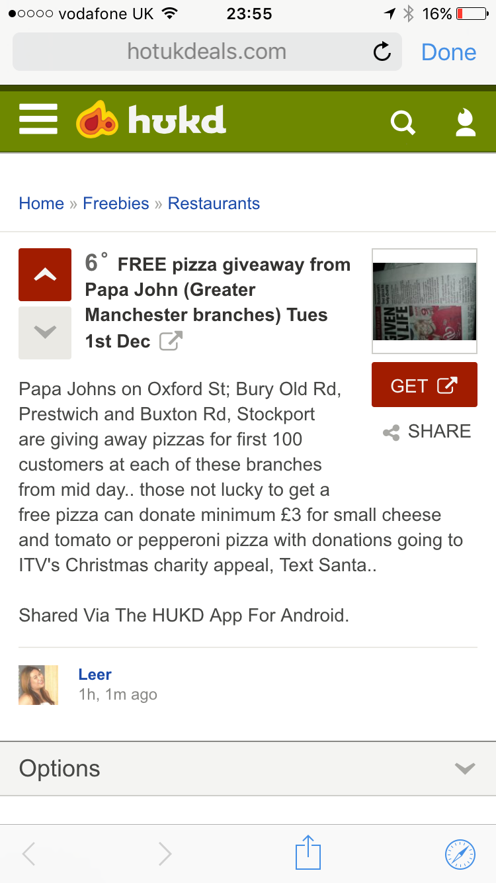

Figure Papa John FREE pizza campaign

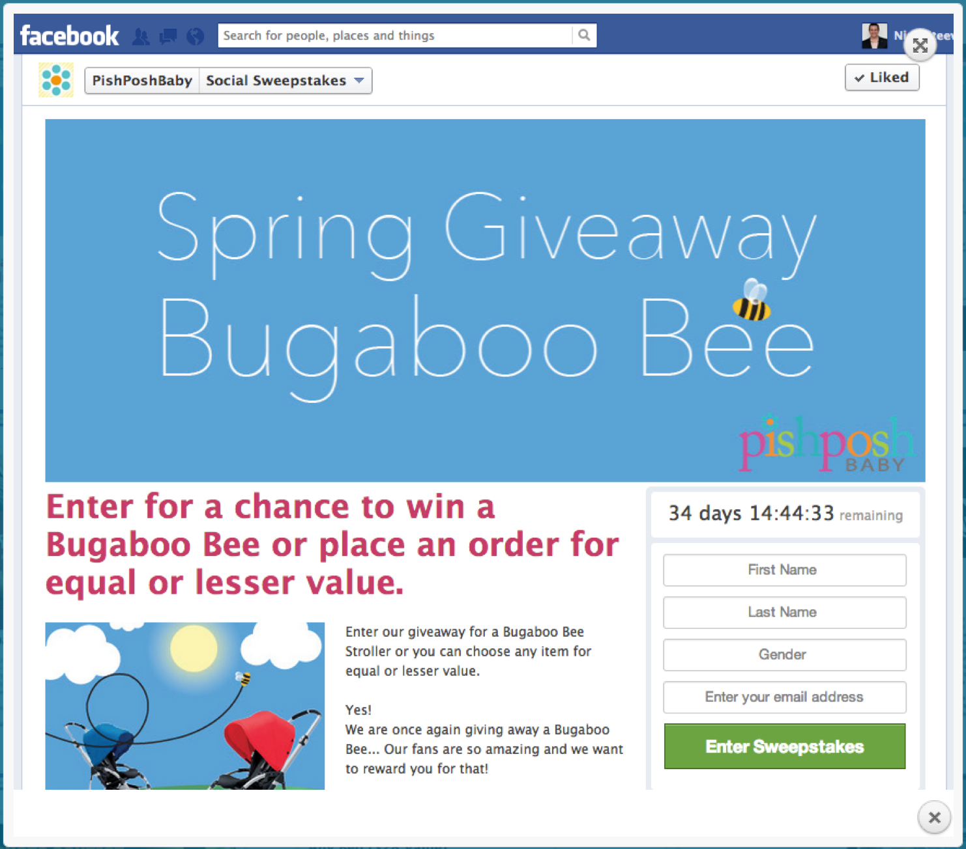

Figure A social media campaign by Pishposh Baby

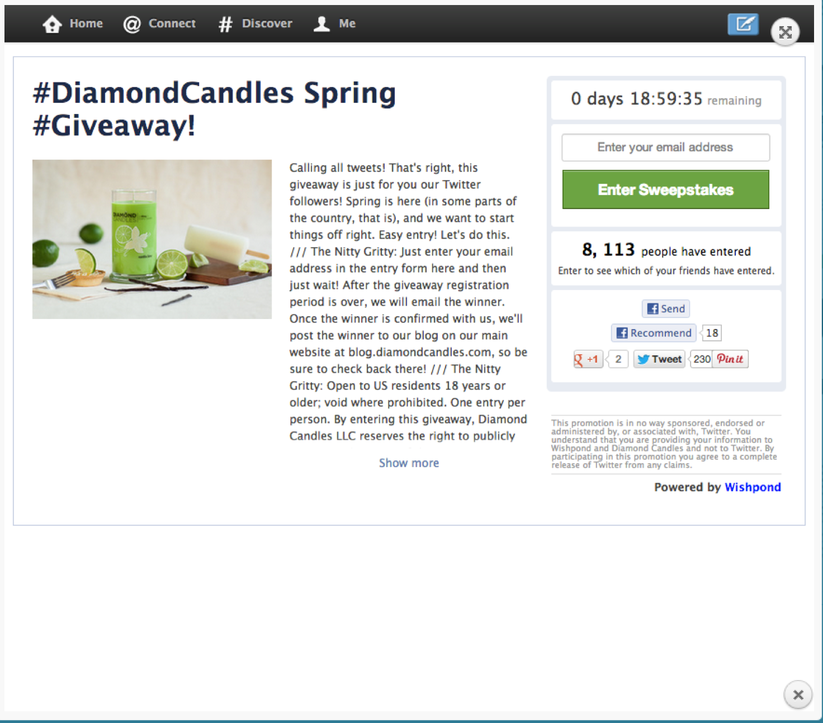

Figure Diamond Candles Spring campaign

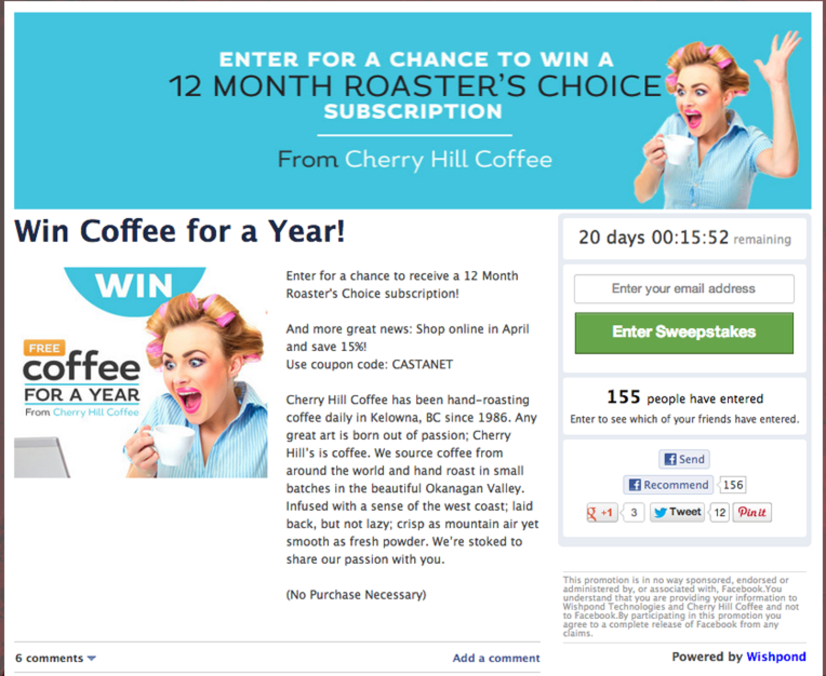

Figure Cherry Hill Caffee campaign

**Appendix 2: First Iteration**

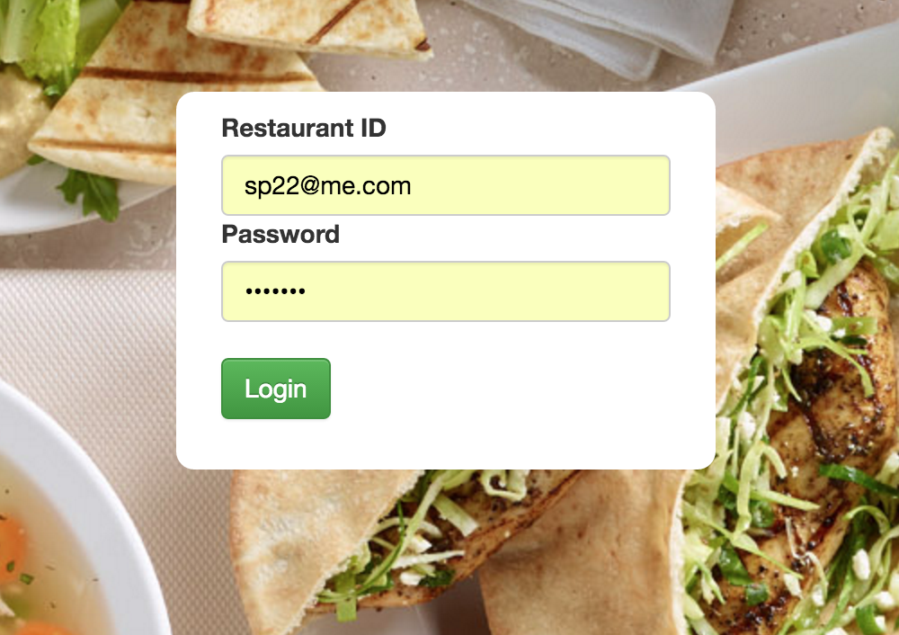

Figure x is a screen shot of the login system for the application. By providing the login credentials the application will access the database and authenticate the user. If the authentication passed the user will be directed to the dashboard.

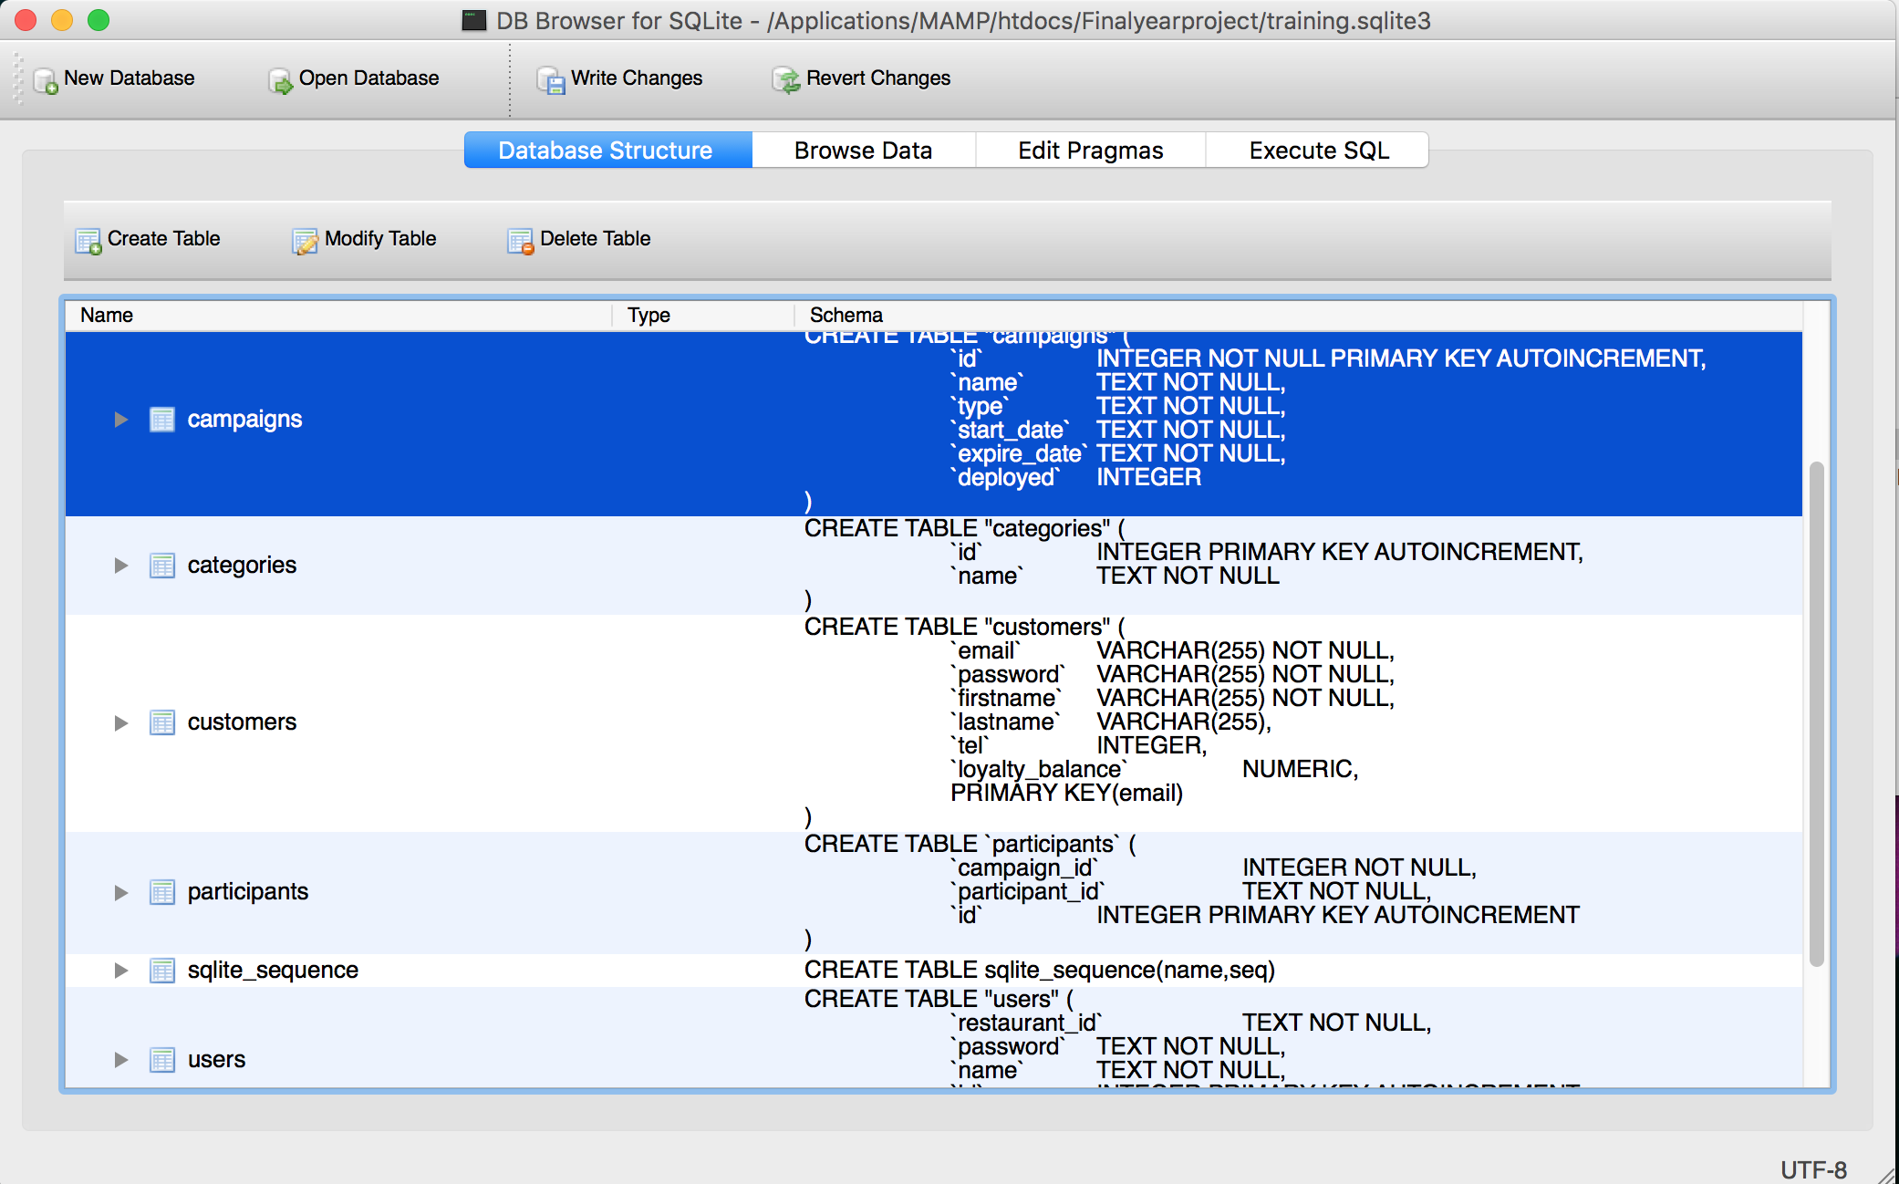

Figure x shows the database schema created for the application, which consist of tables such as campaigns, customers, users, etc.

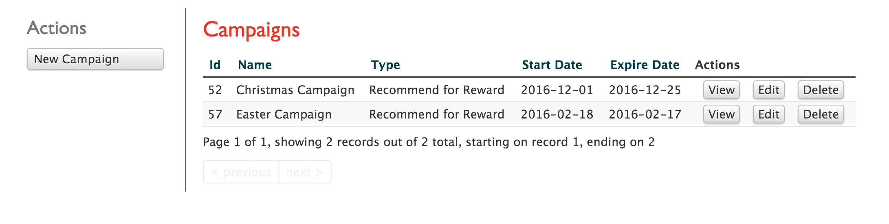

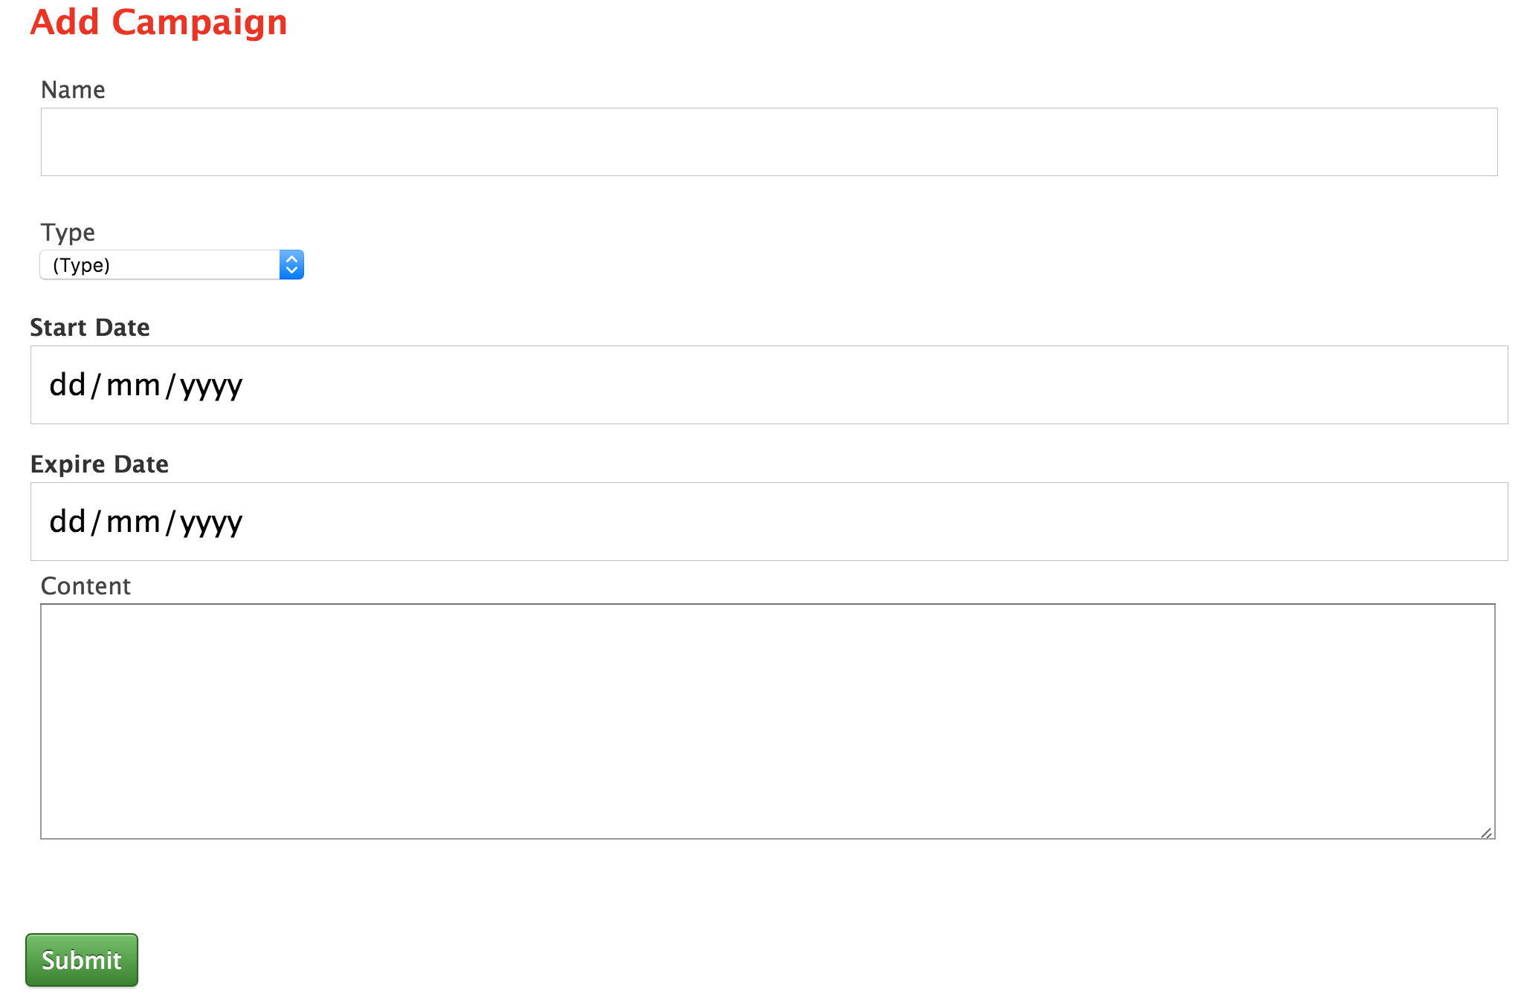Figure x is a screenshot of the dashboard that user gets directed after the authentication passed. This is the initial prototype for the system and it illustrates the exact design as shown in wireframe. In the screenshot, it shows two campaigns currently created and held in the account. Relevant links are provided to enable user to view, edit, or delete each campaign, as well as having the option to even create a new one.

The screenshot shown as figure x is a form that takes the inputs from the user about a new

campaign and saves it as a new record in the database. At this moment the content input doesn’t provide the tools to enable the user to design campaign content page. In the second cycle of the implementation a content page will be created for each containing the contents data provided by the user.

**Appendix 3: Second Iteration**

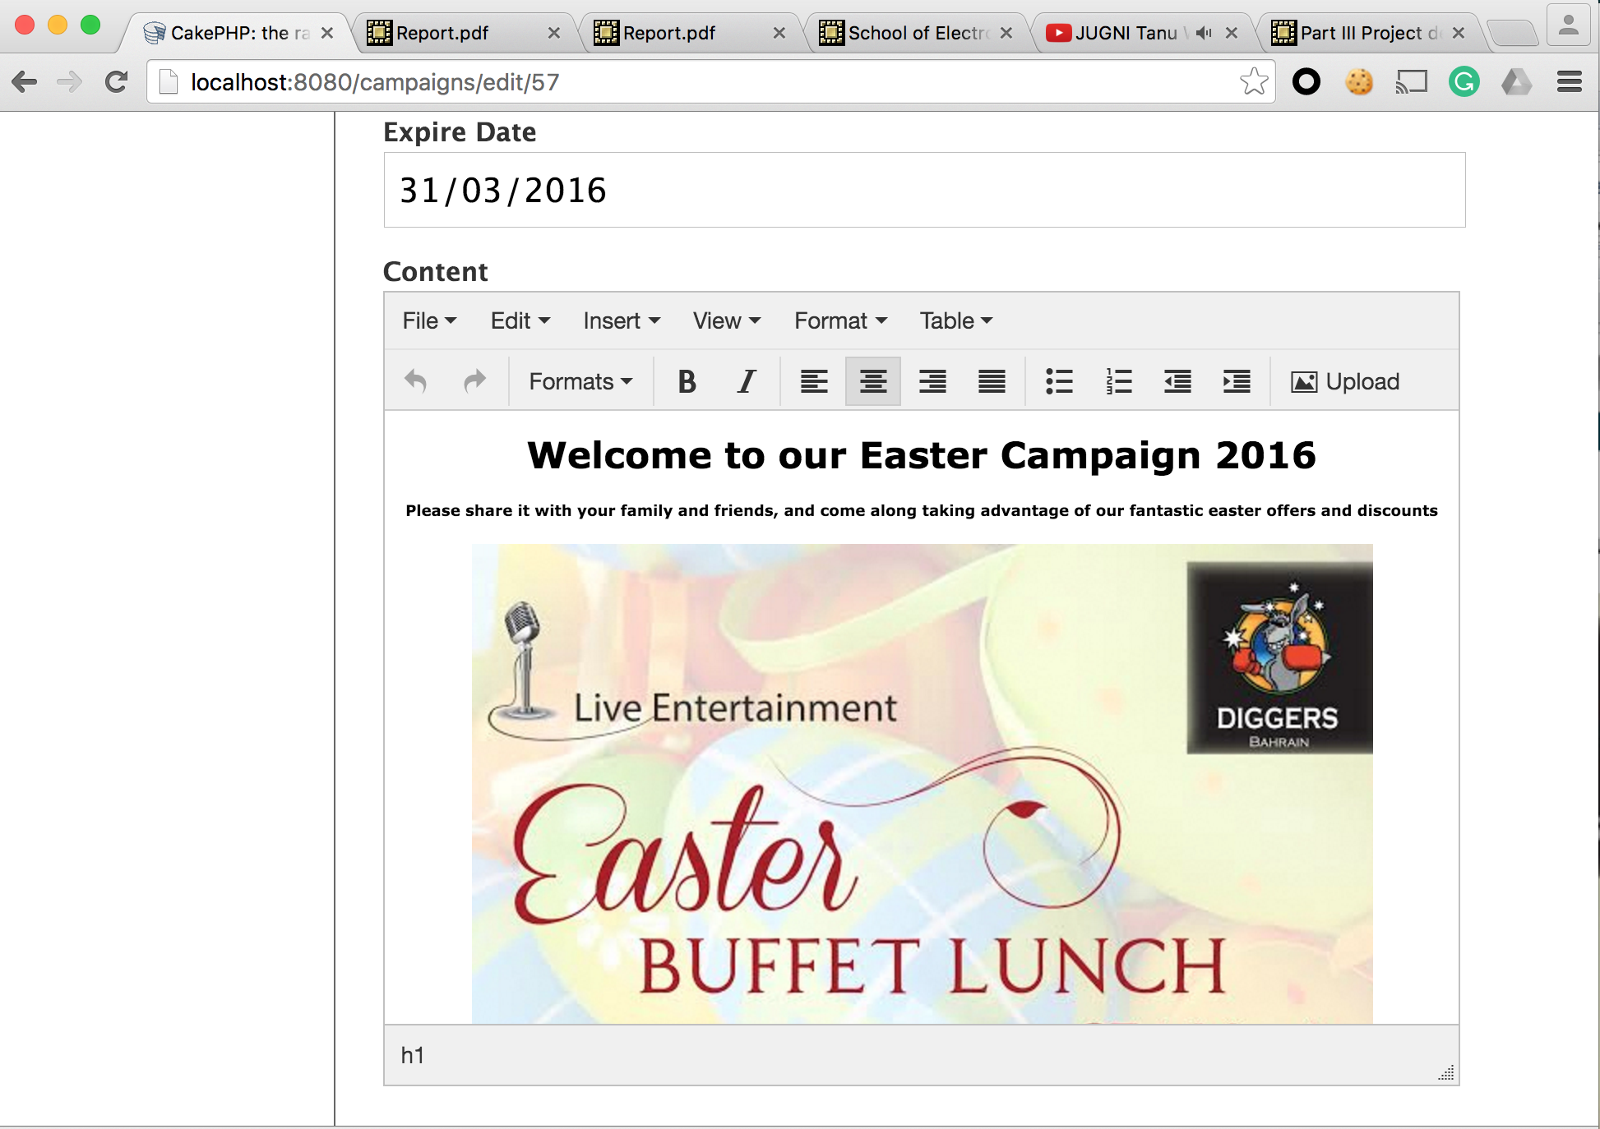

The TinyMCE plugin added to the content text area, which provides the toolbox to design the campaign content page in the browser.

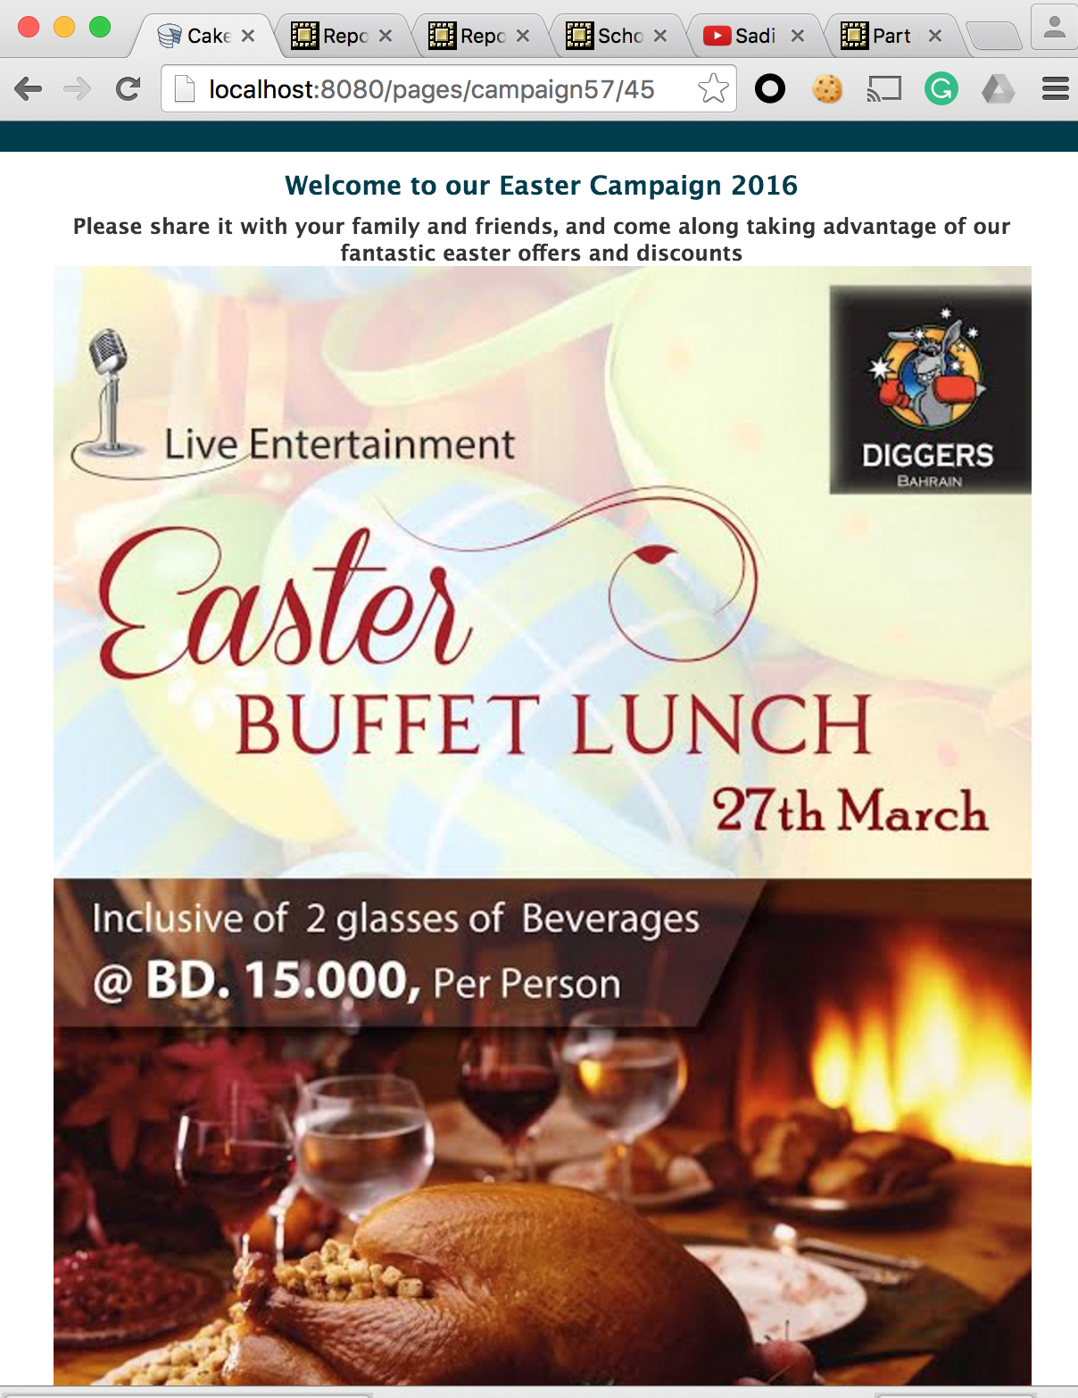

figure x shows a preview of the content page that is shared amount the campaign participants.

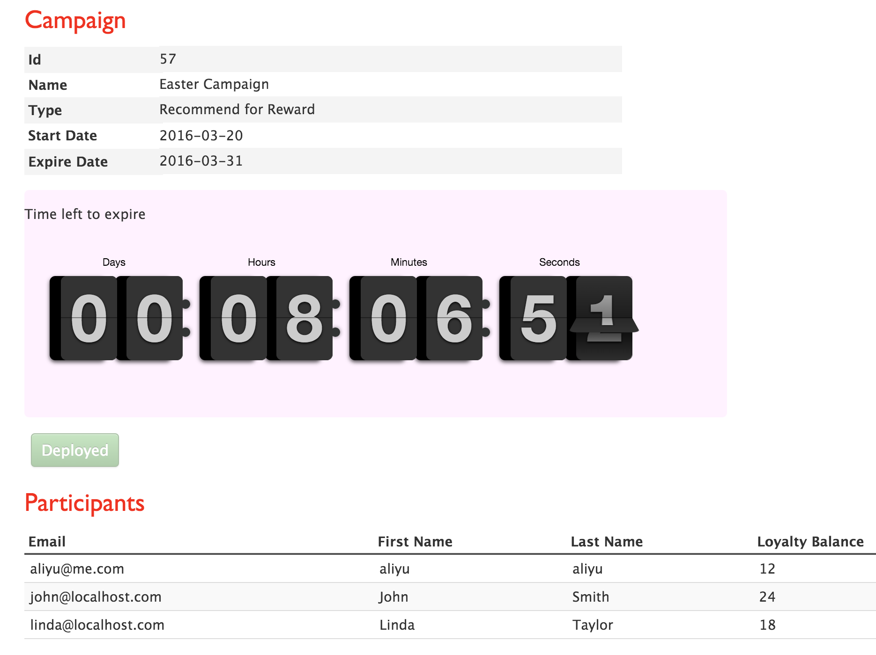

Figure x is a screenshot of the campaign view. When the campaign administrator (the restaurant) view statues of the campaign, the above details are shown.

**Appendix 4: The Survey Questionnaire**

British Dining Social Networks Promotions Survey

1. What online promotions system are you using for advertising your business? Please tick all that apply to you.

Self Owned Website

Wishpond

Self Operated Social Media Accounts

Other: please specify

None

If chosen ‘None’ as your answer, please specify a reason. Please tick all that apply.

Can’t afford fees or time

Lack of technical expertise

Have not heard about online promotions

Other: please specify

2. Do you think British Dining will be a useful technology to promote your business, If so how?

Yes

No

If you have chosen ‘Yes’ please specify how would it be beneficial. Please tick all that apply.

Branding popularity

Increased sales

Expanding Business

Saves advertisement cost

If you have chosen ‘No’ please specify why.

3. Does British Dining seem to be a usable way for you to manage online promotions?

Yes, it looks manageable

No, I will have problems

If chosen ‘No’, please specify the reason. Please tick all that apply.

Don’t have access to the Internet

It is hard to use

Time consuming

4. What promoting plans do you currently use for advertising your business?

E-commerce

Leaflet/flyers

Other: please specify

None

**Appendix 5: Completed Survey**

**Appendix 6: Chi Square Detailed Calculations**

Chi-square formula: $X^{2 }= \sum{\frac{{(Observed Frequencies-Expected Frequencies)}^{2}}{Expected Frequencies}}$

Chi-square = $\frac{{\left(4-2.5\right)}^{2}}{2.5}+ \frac{{\left(1-2.5\right)}^{2}}{2.5}+ \frac{{\left(4-2.5\right)}^{2}}{2.5}+ \frac{{\left(1-2.5\right)}^{2}}{2.5}=3.6$

Degrees of freedom = (Number of categories – 1) => 2-1 = 1

**Chi-square table**

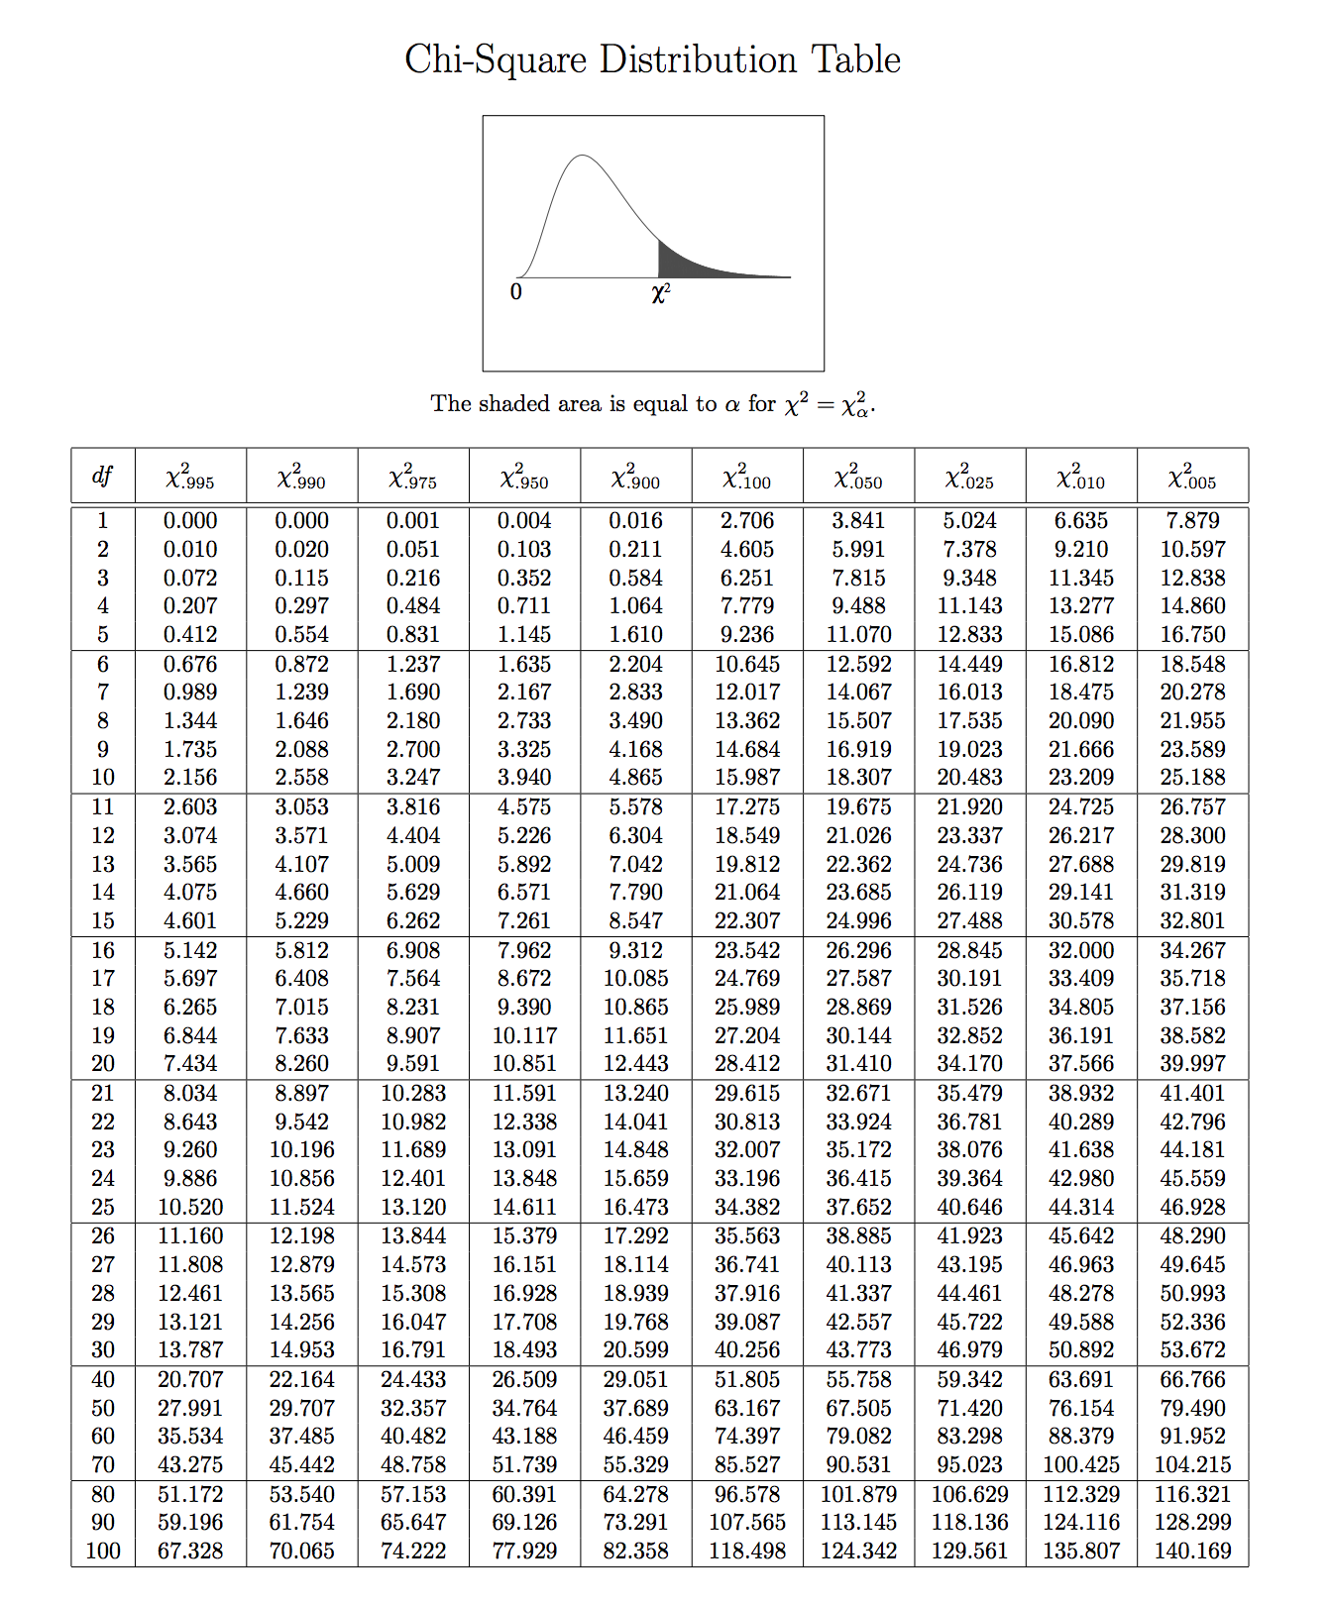

Probability = 0.05 = 5% according to the table above.